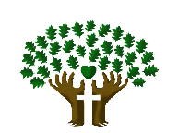
ST. LUKE’S ANGLICAN CHURCH, PALERMO
Palm Sunday
Sunday, March 28, 2021 ◊ 10:30 am

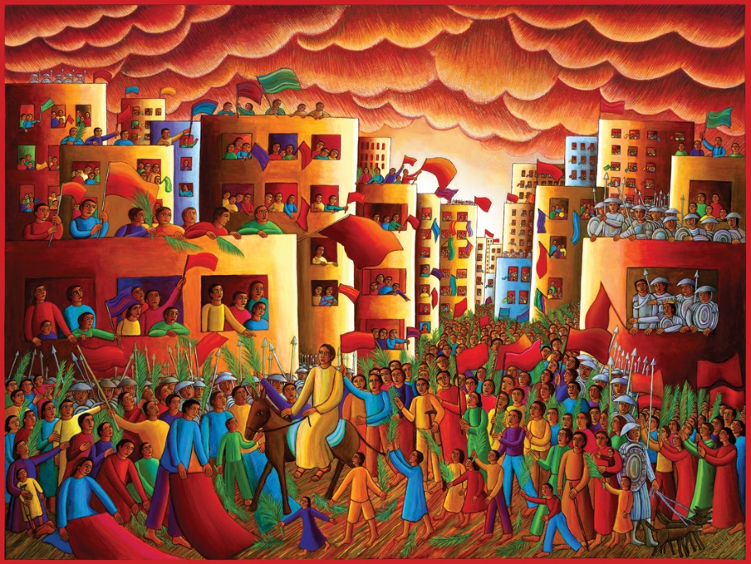

The Reverend Garfield Wu – Presider & Preacher

Welcome to St. Luke’s!

We are glad to be able to worship with you in person. Our service will look a little different than usual week as we take precautions to prevent the spread of COVID-19. Though this time may bring challenges, we know that nothing can separate us from the love of God.

None of us comes to church by accident. No matter what joys, burdens, or problems you bring with you this day, we pray that God’s grace will touch you and fill you with the hope and commitment to live your life with peace, courage, compassion, and love.

THE PROCESSION

Processional Hymn
All Glory, Laud, and Honour – CP 181 (v. 1-3)
Refrain
All glory, laud, and honour,
to thee, Redeemer, King,
to whom the lips of children
made sweet hosannas ring.

1. Thou art the King of Israel
thou David’s royal Son,
who in the Lord’s Name comest
the King and blessed One.
Refrain

2. The company of angels
are praising thee on high,
and we with all creation
in chorus make reply.
Refrain

3. The people of the Hebrews
with palms before thee went;
our praise and prayer and anthems
before thee we present.
Refrain

Greeting
Celebrant: The grace of our Lord Jesus Christ
and the love of God and the fellowship of the Holy Spirit be with you all.
All: And also, with you.
Celebrant: Blessed be God, Father, Son, and Holy Spirit.
All: And blessed be God's kingdom forever. Amen.

Collect for Purity
Celebrant: Almighty God,
All: to whom all hearts are open, all desires known, and from you no secrets are hidden, cleanse the thoughts of our hearts by the inspiration of your Holy Spirit, that we may perfectly love you and worthily magnify your holy name, through Christ our Lord. Amen.

Kyrie Eleison
All: Lord, have mercy upon us,
Christ, have mercy upon us,
Lord, have mercy upon us.

Collect of the Day
Almighty and everliving God, in tender love for all our human race you sent your Son our Saviour Jesus Christ to take our flesh and suffer death upon a cruel cross. May we follow the example of his great humility, and share in the glory of his resurrection; through Jesus Christ our Lord, who is alive and reigns with you and the Holy Spirit, one God, now and forever. Amen.
The Liturgy of the Palms
Celebrant: Blessed is he who comes in the name of the Lord.
All: Hosanna in the highest.
Celebrant: Dear friends in Christ, during Lent we have been preparing for the celebration of our Lord’s paschal mystery. On this day our Lord Jesus Christ entered the holy city of Jerusalem in triumph.
The people welcomed him with palms and shouts of praise, but the path before him led to self-giving, suffering, and death.
Today we greet him as our King, although we know his crown is thorns and his throne a cross. We follow him this week from the glory of the palms to the glory of the resurrection by way of the dark road of suffering and death. United with him in his suffering on the cross, may we share his resurrection and new life. Let us pray.
Assist us mercifully with your help, Lord God of our salvation, that we may enter with joy into the celebration of those mighty acts whereby you give us life and immortality; through Jesus Christ our Lord. Amen.

THE PROCLAMATION OF THE WORD

A Reading from the Book of Isaiah
Isaiah 50:4-9a
The Lord God has given me
the tongue of a teacher,
that I may know how to sustain
the weary with a word.
Morning by morning he wakens—
wakens my ear
to listen as those who are taught.
The Lord God has opened my ear,
and I was not rebellious,
I did not turn backward.
I gave my back to those who struck me,
and my cheeks to those who pulled out the beard;
I did not hide my face
from insult and spitting.

The Lord God helps me;
therefore I have not been disgraced;
therefore I have set my face like flint,
and I know that I shall not be put to shame;
he who vindicates me is near.
Who will contend with me?
Let us stand up together.
Who are my adversaries?
Let them confront me.
It is the Lord God who helps me;
who will declare me guilty?
All of them will wear out like a garment;
the moth will eat them up.
The Word of the Lord.
Thanks be to God.
Gradual Hymn
Ride On, Ride on in Majesty – CP 182 (v. 1, 2, 4, 5)
1. Ride on, ride on in majesty!
Hark all the tribes “Hosanna” cry;
O Saviour meek, pursue thy road
with palms and scattered garments strowed.

2. Ride on, ride on in majesty!
In lowly pomp, ride on to die;
O Christ, thy triumphs now begin
o’er captive death and conquered sin.

4. Ride on, ride on in majesty!
Thy last and fiercest strife is nigh:
The Father on his sapphire throne
expects his own anointed Son.

The Gospel
Mark 11:1-11
The Lord be with you.
And also, with you.
The Holy Gospel of our Lord Jesus Christ, according to Luke.
Glory to you, Lord Jesus Christ.
When they were approaching Jerusalem, at Bethphage and Bethany, near the Mount of Olives, he sent two of his disciples and said to them, “Go into the village ahead of you, and immediately as you enter it, you will find tied there a colt that has never been ridden; untie it and bring it. If anyone says to you, ‘Why are you doing this?’ just say this, ‘The Lord needs it and will send it back here immediately.’” They went away and found a colt tied near a door, outside in the street. As they were untying it, some of the bystanders said to them, “What are you doing, untying the colt?” They told them what Jesus had said; and they allowed them to take it. Then they brought the colt to Jesus and threw their cloaks on it; and he sat on it. Many people spread their cloaks on the road, and others spread leafy branches that they had cut in the fields. Then those who went ahead and those who followed were shouting,
“Hosanna!
Blessed is the one who comes in the name of the Lord!
Blessed is the coming kingdom of our ancestor David!
Hosanna in the highest heaven!”
Then he entered Jerusalem and went into the temple; and when he had looked around at everything, as it was already late, he went out to Bethany with the twelve.
The Gospel of Christ.
Praise to you, Lord Jesus Christ.

5. Ride on, ride on in majesty!
In lowly pomp, ride on to die;
bow thy meek head to mortal pain;
then take, O God, thy power and reign.
The Sermon
By the Rev. Garfield Wu

The Apostle’s Creed
Celebrant: | Let us confess the faith of our baptism as we say,
All: | I believe in God, the Father almighty, creator of heaven and earth.  I believe in Jesus Christ, his only Son, our Lord. He was conceived by the power of the Holy Spirit and born of the Virgin Mary. He suffered under Pontius Pilate, was crucified, died, and was buried. He descended to the dead. On the third day, he rose again. He ascended into heaven and is seated at the right hand of the Father. He will come again to judge the living and the dead.  I believe in the Holy Spirit, the holy catholic Church, the communion of saints, the forgiveness of sins, the resurrection of the body, and the life everlasting. Amen.

The Prayers of the People
Litany #14 – Lent (from BAS p. 121)
Celebrant: | With confidence and trust let us pray to the Lord, saying, “Lord, have mercy.”  For the one holy catholic and apostolic Church throughout the world, we pray to you, Lord.
All: | Lord, have mercy.
Celebrant: | For the mission of the Church, that in faithful witness it may preach the gospel to the ends of the earth, we pray to you, Lord.
All: | Lord, have mercy.
Celebrant: | For those preparing for baptism and for their teachers and sponsors, we pray to you, Lord.
All: | Lord, have mercy.
Celebrant: | For peace in the world, that a spirit of respect and reconciliation may grow among nations and peoples, we pray to you, Lord.
All: | Lord, have mercy.
Celebrant: | For the poor, the persecuted, the sick, and all who suffer; for refugees, prisoners, and all in danger; that they may be relieved and protected, we pray to you, Lord.
All: | Lord, have mercy.
Celebrant: | For all whom we have injured or offended, we pray to you, Lord.
All: | Lord, have mercy.
Celebrant: | For grace to amend our lives and to further the reign of God, we pray to you, Lord.
All: | Lord, have mercy.

Family Cycle of Prayer:
Catherine & Rohit Dhamija, Gladis & Joseph Di Paolo, Patrick Donnelly, Colleen & Adam Douglas, Gary Duncan, and their families.

In the Diocese of Niagara:
St. Paul, Jarvis; the Reverend Canon Richard Moorse, Rector; and all the people of that parish.
Let us take a moment to say the names of those we know to be in need, or allow those things are weighing heavy our on our hearts this day to come before the Lord. […]
So, we commend ourselves and all for whom we pray to the mercy and protection of our heavenly Father. Amen

Confession and Absolution
Celebrant: | Dear friends in Christ,  God is steadfast in love and infinite in mercy; he welcomes sinners and invites them to his table. Let us confess our sins, confident in God's forgiveness.
Celebrant: | Most merciful God,
All: | we confess that we have sinned against you in Thought, Word, and Deed, by what we have done, and by what we have left undone. We have not loved you with our whole heart; we have not loved our neighbours as ourselves. We are truly sorry, and we humbly repent. For the sake of your Son Jesus Christ, have mercy on us and forgive us, that we may delight in your will, and walk in your ways, to the glory of your name. Amen
Celebrant: | Almighty God have mercy upon you, pardon and deliver you from all your sins, confirm and strengthen you in all goodness, and keep you in eternal life; through Jesus Christ, our Lord.
All: | Amen.

The Peace
The peace of the Lord be always with you.
And also with you.
THE CELEBRATION OF THE EUCHARIST
Preparation of the Gifts
Offertory Hymn
One Bread, One Body, One Lord of All – CP 73

Refrain
One bread, one body, one Lord of all,
one cup of blessing which we bless –
and we, though many, throughout the earth,
we are one body in this one Lord.

1. Gentile or Jew, servant or free
woman or man, no more.
Refrain

2. Many the gifts, many the works,
one in the Lord of all.
Refrain

3. Grain for the fields, scattered and grown,
gathered to one for all.
Refrain

The Prayer over the Gifts
Gracious God, the suffering and death of Jesus, your only Son, makes us pleasing in your sight. Alone we can do nothing, but through his sacrifice, may we receive your love and mercy. Amen.

The Great Thanksgiving (Eucharistic Prayer #3)
Celebrant:  People: | The Lord be with you.  And also, with you
Celebrant:  People: | Lift up your hearts.  We lift them to the Lord
Celebrant:  People: | Let us give thanks to the Lord our God.  It is right to give our thanks and praise.
Celebrant: | Blessed are you, gracious God, creator of heaven and earth; we give you thanks and praise through Jesus Christ our Lord, who for our sins was lifted high upon the cross, that he might draw the whole world to himself. By his suffering and death, he became the source of eternal salvation for all who put their trust in him. Therefore with all the host of heaven who gather around your throne and the Lamb, we raise our voices to proclaim the glory of your name.
All: | Holy, holy, holy Lord,  God of power and might, heaven and earth are full of your glory.  Hosanna in the highest.  Blessed is he who comes in the name of the Lord. Hosanna in the highest.
Celebrant: | We give thanks to you, Lord our God,  for the goodness and love you have made known to us in creation; in calling Israel to be your people, in your Word spoken through the prophets; and above all in the Word made flesh, Jesus, your Son.  For in these last days you sent him to be incarnate from the Virgin Mary, to be the Saviour and Redeemer of the world. In him, you have delivered us from evil, and made us worthy to stand before you. In him, you have brought us out of error into truth, out of sin into righteousness, out of death into life.  On the night he was handed over to suffering and death, a death he freely accepted, our Lord Jesus Christ took bread; and when he had given thanks to you, he broke it, and gave it to his disciples, and said, "Take, eat: this is my body which is given for you. Do this for the remembrance of me."  After supper, he took the cup of wine; and when he had given thanks, he gave it to them, and said, "Drink this, all of you: this is my blood of the new covenant, which is shed for you and for many for the forgiveness of sins. Whenever you drink it, do this for the remembrance of me." Therefore, Father, according to his command,
All: | We remember his death,  We proclaim his resurrection,  We await his coming in glory;
Celebrant: | and we offer our sacrifice of praise and thanksgiving to you, Lord of all; presenting to you, from your creation, this bread and this wine.  We pray you, gracious God, to send your Holy Spirit upon these gifts, that they may be the sacrament of the body of Christ  and his blood of the new covenant. Unite us to your Son in his sacrifice, that we made acceptable in him, maybe sanctified by the Holy Spirit. In the fullness of time, reconcile all things in Christ, and make them new, and bring us to that city of light  where you dwell with all your sons and daughters; through Jesus Christ our Lord,  the firstborn of all creation, the head of the Church, and the author of our salvation.  By whom, and with whom, and in whom,  in the unity of the Holy Spirit,  all honour and glory are yours, almighty Father, now and for ever.
People: | Amen.

The Lord's Prayer
Celebrant: | And now, as our Saviour Christ has taught us, we are bold to say:
All: | Our Father, who art in heaven,  hallowed be thy name,  thy kingdom come, thy will be done,  on earth as it is in heaven.  Give us this day our daily bread.  And forgive us our trespasses,  as we forgive those, who trespass against us.  And lead us not into temptation,  but deliver us from evil.  For thine is the kingdom,  the power, and the glory,  forever and ever. Amen.

The Breaking of the Bread
Celebrant: | We break this bread,
All: | Communion in Christ’s body once broken.
Celebrant: | Let your Church be the wheat which bears its fruit in dying.
All: | If we have died with him,  we shall live with him;  if we hold firm,  we shall reign with him.

The Communion
Celebrant:  All: | The gifts of God for the people of God.  Thanks be to God.
All: | Lamb of God, you take away the sins of the world: have mercy on us.  Lamb of God, you take away the sins of the world: have mercy on us.  Lamb of God, you take away the sins of the world: grant us peace.

The Eucharist
You are encouraged to receive the Holy Communion, standing or kneeling at the communion rail or at your request in your seat. In accordance with COVID-19 health guidelines, only the host will be distributed. Let us know if you require a gluten-free wafer. If you prefer a blessing only, please indicate so by crossing your arms. If you find it difficult to get to the altar, we will be honoured to bring the Holy Communion to you.

THE SENDING OF GOD'S PEOPLE

The Prayer after Communion
God our help and strength, you have satisfied our hunger with this eucharistic food. Strengthen our faith, that through the death and resurrection of your Son, we may be led to salvation, for he is Lord now and forever. Amen.

Doxology
Celebrant: | Glory to God
All: | whose power, working in us, can do infinitely more than we can ask or imagine. Glory to God from generation to generation, in the Church and in Christ Jesus, forever and ever. Amen.
Blessing
The Celebrant blesses the people, and all respond,
Amen.

Announcements

Recessional Hymn
Praise to the Lord – SFGP 17

1. Praise to the Lord, all of you, God’s servants!
Blessed be the name of our God now and ever.
From the rising up of the sun
may the Lord be praised,
praise to the name of the Lord!

2. There is none like our God in the heav’ns or on earth,
who lifts the weak out of dust placing them with the mighty,
who throned on high looks down so low:
may the Lord be praised,
praise to the name of the Lord!

The Dismissal
Go in peace. Serve the Lord, love others.
Thanks be to God.

Postlude
This liturgy is used with the permission of the Bishop of Niagara.
This service is adapted from The Book of Alternative Services (BAS). The Book of Alternative Services, copyright © 2019 by the General Synod of the Anglican Church of Canada; all rights reserved; reproduced under license. Common Worship, copyright © 2019 by the Archbishop's Council; used by permission; all rights reserved.

READINGS FOR NEXT SUNDAY
Isaiah 25:6-9; Mark 16:1-8

ANNOUNCEMENTS
MORNING PRAYER AND BIBLE STUDY
Each Wednesday at 9:30 am
Our Morning Prayer services continue at St. Luke’s and online! Join us for a nourishing liturgy followed by a short Bible Study each Wednesday morning. This is a fun and friendly time of discussion and learning. No prior knowledge of the Bible is required. Come and check it out!

This Wednesday’s Readings:
Jeremiah 17:5-10, 14-17; Psalm 55;
Philippians 4:1-13; John 13:21-32

Contact: garfield@stlukepalermo.ca
or 647-878-8650 for details!

Join Us During Holy Week and Easter!
This year, our Holy Week observances at St. Luke's will look different than most other years as we continue to transition through the COVID-19 pandemic.

- On Maundy Thursday, April 1 at 6 pm, we will join the Bishop's online service using the Niagara Diocese's Facebook page.
- On Good Friday, April 2 at 10 am, we will join the Bishop's online service on Facebook again.
- On Easter Sunday, April 4 at 10:30 am, we will celebrate the Resurrection of the Lord at St. Luke's via Zoom.
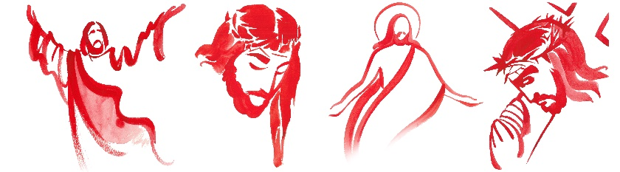

Support St. Luke’s and Double Your Donation!
Exciting news! As we have been working to stabilize our finances this year, two parishioners, Jo Stadnyk and and Aileen Li have generously offered to match donations to St. Luke's, above and beyond regular offerings, up to $1,000. This would give St. Luke’s a $2,000 boost!

Send in your donations to have your gift's impact DOUBLED! You can send a cheque, e-transfer or use our Canada Helps page. Please include the note "Donation Matching Campaign 2021" with your gift to ensure it is counted properly.

E-transfers can be sent to our Treasurer at: treasurer@stlukepalermo.ca

Thank you to Jo, Aileen, and all the generous donors who have made this possible, and to all parishioners who make our ministries happen!

St. Luke’s Palermo
Spring 2021 Gift Card Sale!
St. Luke’s Gift Card Sale is underway! We are pleased to announce that the sale deadline has been extended to Sunday, April 11 to allow for more orders.

Let your friends and neighbours know that they can buy gift cards from many popular retailers, and support St. Luke’s, Palermo’s vital ministries and community services at the same time. While you get the full value of your card, a portion of the sale is donated to support our operations.

Orders are due Sunday, April 11.

Visit our website at
stlukepalermo.ca/giftcardsale/ to shop our gift cards!

St. Luke's Socializing Seniors Virtually Program Continues this Wednesday!
Program Runs each Wednesday at 11 am until May 26
St. Luke's is happy that our Seniors' Virtual Social Hour with Gabriella Mostacci Tolic, RP, MACP, is off to a great start. You are invited to participate in our program each Wednesday at 11 am, up to and including May 26.

An exciting line up of group and individual workshops will be provided.

Please email us to register at office@stlukepalermo.ca and receive the Zoom Link. Please feel free to share this event with your friends, family and neighbours!

Health and Safety Protocol:

- Always wear a mask when in the Church.
- Please sanitize your hands as you come into the Church, going up for communion and coming down after communion and when you are leaving the building.
- Please take your bulletin home with you.

If you have any of the following symptoms, please contact your family doctor.

Symptoms of COVID-19 can vary from person to person. Symptoms may also vary in different age groups. Some of the more commonly reported symptoms include:
- new or worsening cough
- shortness of breath or difficulty breathing
- temperature equal to or over 38°C
- feeling feverish
- chills
- fatigue or weakness
- muscle or body aches
- new loss of smell or taste
- headache
- gastrointestinal symptoms (abdominal pain, diarrhea, vomiting)
- feeling very unwell
Children have been more commonly reported to have abdominal symptoms and skin changes or rashes.
In severe cases, the infection can lead to death.
Symptoms may take up to 14 days to appear after exposure to COVID-19.
Evidence indicates that the virus can be transmitted to others from someone who is infected but not showing symptoms. This includes people who:
- have not yet developed symptoms (pre-symptomatic)
- never develop symptoms (asymptomatic)
While experts know that these kinds of transmissions are happening among those in close contact or in close physical settings, it is not known to what extent. This means it is extremely important to follow the proven preventative measures.
For more information, please look online at

https://www.canada.ca/en/public-health/services/diseases/coronavirus-disease-covid-19.html

Thank you for joining us today.
We do hope that you will come again.
fb.me/stlukepalermo

@stlukepalermo

@stlukepalermo

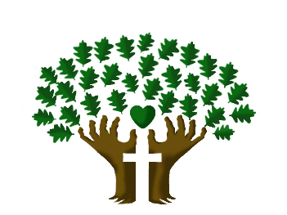

St. Luke’s Anglican Church, Palermo
3114 Dundas Street West,
Oakville, Ontario, L6M 4J3
Tel: 905-825-3364
Email: office@stlukepalermo.ca
Website: stlukepalermo.ca

Rector: The Rev. Garfield Wu
Email: rector@stlukepalermo.ca
Tel: 647-878-8650

Reader: Dean Correia
Music Director: Janet Correia
Duty Warden: Pam (Feng) Pan
Greeter: Peter Malue

