ST. LUKE’S ANGLICAN CHURCH, PALERMO
Fifth Sunday in Lent
Sunday, March 21, 2021 ◊ 10:30 am

The Reverend Garfield Wu – Presider & Preacher

Welcome to St. Luke’s!

We are glad to be able to worship with you in person. Our service will look a little different than usual week as we take precautions to prevent the spread of COVID-19. Though this time may bring challenges, we know that nothing can separate us from the love of God.

None of us comes to church by accident. No matter what joys, burdens, or problems you bring with you this day, we pray that God’s grace will touch you and fill you with the hope and commitment to live your life with peace, courage, compassion, and love.

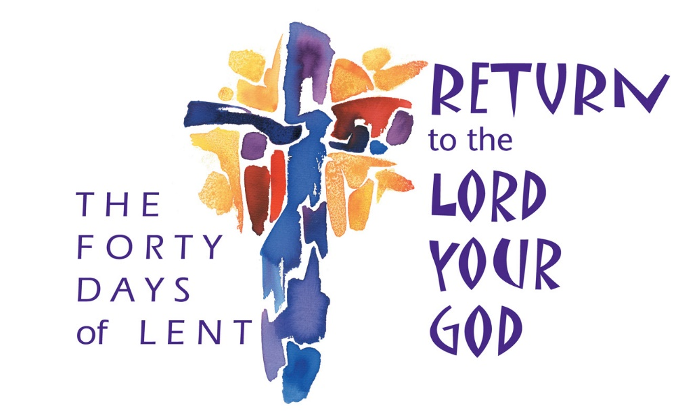

THE GATHERING OF THE COMMUNITY

Processional Hymn
God, Your Glorious Presence – CP 337
1. God, your glorious presence
draws us to adore you
and with awe appear before you.
In your holy temple
all keep mystic silence,
prostrate lie with deepest reverence.
You alone, God we own,
you our God and Saviour:
praise your name forever.

2. In God’s glorious presence
hear the harps resounding!
See the hosts the throne surrounding!
“Holy, holy, holy”,
hear the hymn ascending,
angels, saints, their voices blending!
Bow your ear to us here:
hear, O Christ, the praises
that your church now raises.

3. Fount of endless blessing,
purify my spirit,
trusting only in your merit
Like the holy angels
who behold your splendour,
may I ceaseless worship render.
Let your will, ever still
rule your church terrestrial,
as the hosts celestial.
Greeting
Celebrant: The grace of our Lord Jesus Christ
and the love of God and the fellowship of the Holy Spirit be with you all.
All: And also, with you.
Celebrant: Blessed be God, Father, Son, and Holy Spirit.
All: And blessed be God's kingdom forever. Amen.
Collect for Purity
Celebrant: Almighty God,
All: to whom all hearts are open, all desires known, and from you no secrets are hidden, cleanse the thoughts of our hearts by the inspiration of your Holy Spirit, that we may perfectly love you and worthily magnify your holy name, through Christ our Lord. Amen.

Kyrie Eleison
All: Lord, have mercy upon us,
Christ, have mercy upon us,
Lord, have mercy upon us.

Collect of the Day
Most merciful God, by the death and resurrection of your Son Jesus Christ, you created humanity anew. May the power of his victorious cross transform those who turn in faith to him who lives and reigns with you and the Holy Spirit, one God, now and forever. Amen.

THE PROCLAMATION OF THE WORD

A Reading from the Book of Jeremiah
Jeremiah 31:31–34
The days are surely coming, says the Lord, when I will make a new covenant with the house of Israel and the house of Judah. It will not be like the covenant that I made with their ancestors when I took them by the hand to bring them out of the land of Egypt—a covenant that they broke, though I was their husband, says the Lord. But this is the covenant that I will make with the house of Israel after those days, says the Lord: I will put my law within them, and I will write it on their hearts; and I will be their God, and they shall be my people. No longer shall they teach one another, or say to each other, “Know the Lord,” for they shall all know me, from the least of them to the greatest, says the Lord; for I will forgive their iniquity, and remember their sin no more.
The Word of the Lord.
Thanks be to God.

Gradual Hymn
Blest Be the Tie that Binds – SFGP 9
1. Blest be the tie that binds
our hearts in Christian love;
the unity of heart and mind
is like to that above.

2. Before our Maker’s throne
we pour ardent prayers;
our fears, our hopes, our aims are one,
our comforts and our cares.

3. We share each other’s woes,
each other’s burdens bear;
and often for each other flows
the sympathising tear.

The Gospel
John 12:20–33
The Lord be with you.
And also, with you.
The Holy Gospel of our Lord Jesus Christ, according to Luke.
Glory to you, Lord Jesus Christ.
Now among those who went up to worship at the festival were some Greeks. They came to Philip, who was from Bethsaida in Galilee, and said to him, “Sir, we wish to see Jesus.” Philip went and told Andrew; then Andrew and Philip went and told Jesus. Jesus answered them, “The hour has come for the Son of Man to be glorified. Very truly, I tell you, unless a grain of wheat falls into the earth and dies, it remains just a single grain; but if it dies, it bears much fruit. Those who love their life lose it, and those who hate their life in this world will keep it for eternal life. Whoever serves me must follow me, and where I am, there will my servant be also. Whoever serves me, the Father will honor.
“Now my soul is troubled. And what should I say—‘Father, save me from this hour’? No, it is for this reason that I have come to this hour. Father, glorify your name.” Then a voice came from heaven, “I have glorified it, and I will glorify it again.” The crowd standing there heard it and said that it was thunder. Others said, “An angel has spoken to him.” Jesus answered, “This voice has come for your sake, not for mine. Now is the judgment of this world; now the ruler of this world will be driven out. And I, when I am lifted up from the earth, will draw all people to myself.” He said this to indicate the kind of death he was to die.
The Gospel of Christ.
Praise to you, Lord Jesus Christ.

4. This glorious hope revives
our courage on the way;
that we shall live in perfect love
in God’s eternal day.

The Sermon
By the Rev. Garfield Wu

The Apostle’s Creed
Celebrant: | Let us confess the faith of our baptism as we say,
All: | I believe in God, the Father almighty, creator of heaven and earth.  I believe in Jesus Christ, his only Son, our Lord. He was conceived by the power of the Holy Spirit and born of the Virgin Mary. He suffered under Pontius Pilate, was crucified, died, and was buried. He descended to the dead. On the third day, he rose again. He ascended into heaven and is seated at the right hand of the Father. He will come again to judge the living and the dead.  I believe in the Holy Spirit, the holy catholic Church, the communion of saints, the forgiveness of sins, the resurrection of the body, and the life everlasting. Amen.

The Prayers of the People
Litany #14 – Lent (from BAS p. 121)
Celebrant: | With confidence and trust let us pray to the Lord, saying, “Lord, have mercy.”  For the one holy catholic and apostolic Church throughout the world, we pray to you, Lord.
All: | Lord, have mercy.
Celebrant: | For the mission of the Church, that in faithful witness it may preach the gospel to the ends of the earth, we pray to you, Lord.
All: | Lord, have mercy.
Celebrant: | For those preparing for baptism and for their teachers and sponsors, we pray to you, Lord.
All: | Lord, have mercy.
Celebrant: | For peace in the world, that a spirit of respect and reconciliation may grow among nations and peoples, we pray to you, Lord.
All: | Lord, have mercy.
Celebrant: | For the poor, the persecuted, the sick, and all who suffer; for refugees, prisoners, and all in danger; that they may be relieved and protected, we pray to you, Lord.
All: | Lord, have mercy.
Celebrant: | For all whom we have injured or offended, we pray to you, Lord.
All: | Lord, have mercy.
Celebrant: | For grace to amend our lives and to further the reign of God, we pray to you, Lord.
All: | Lord, have mercy.

Family Cycle of Prayer:
Simone & Maurizio Chen, Sheila Clarke, Dean & Janet Correia, Bradley & Kristen Cousins, Wendy & Carl Cousins, Hugh & Leasa Cumming, and their families.

In the Diocese of Niagara:
St. Stephen-on-the-Mount, Hamilton; the Rev. Canon Robert Brownlie, Priest-in-Charge; and all the people of that parish.
Let us take a moment to say the names of those we know to be in need, or allow those things are weighing heavy our on our hearts this day to come before the Lord. […]
So, we commend ourselves and all for whom we pray to the mercy and protection of our heavenly Father. Amen

Confession and Absolution
Celebrant: | Dear friends in Christ,  God is steadfast in love and infinite in mercy; he welcomes sinners and invites them to his table. Let us confess our sins, confident in God's forgiveness.
Celebrant: | Most merciful God,
All: | we confess that we have sinned against you in Thought, Word, and Deed, by what we have done, and by what we have left undone. We have not loved you with our whole heart; we have not loved our neighbours as ourselves. We are truly sorry, and we humbly repent. For the sake of your Son Jesus Christ, have mercy on us and forgive us, that we may delight in your will, and walk in your ways, to the glory of your name. Amen
Celebrant: | Almighty God have mercy upon you, pardon and deliver you from all your sins, confirm and strengthen you in all goodness, and keep you in eternal life; through Jesus Christ, our Lord.
All: | Amen.
The Peace
The peace of the Lord be always with you.
And also with you.

THE CELEBRATION OF THE EUCHARIST
Preparation of the Gifts
Offertory Hymn
Jesus, to Your Table Led – SFGP 15

1. Jesus, to your table led,
now let every heart be fed
with the true and living bread.

2. When we taste the mystic wine,
of your outpoured blood the sign,
fill our hearts with love divine.

3. While upon your cross we gaze,
mourning o’er our sinful ways,
turn our sadness into praise.

4. Draw us to your wounded side,
whence there flowed the healing tide;
there our sins and sorrows hide.

5. From the bonds of sin release;
cold and wav’ring faith increase;
Lamb of God, grant us your peace.

The Prayer over the Gifts
Eternal God, your only Son suffered death upon the cross to bring the world salvation. Accept the praise and thanksgiving we offer you this day, in the name of Jesus Christ the Lord. Amen.
The Great Thanksgiving (Eucharistic Prayer #2)
Celebrant:  People: | The Lord be with you.  And also, with you
Celebrant:  People: | Lift up your hearts.  We lift them to the Lord.
Celebrant:  People: | Let us give thanks to the Lord our God.  It is right to give our thanks and praise.
Celebrant: | We give you thanks and praise, almighty God, through your beloved Son, Jesus Christ, our Saviour and Redeemer. He is your living Word, through whom you have created all things.  By the power of the Holy Spirit he took flesh of the Virgin Mary and shared our human nature. He lived and died as one of us, to reconcile us to you, the God and Father of all.  In fulfilment of your will he stretched out his hands in suffering, to bring release to those who place their hope in you; and so he won for you a holy people.  He chose to bear our griefs and sorrows, and to give up his life on the cross, that he might shatter the chains of evil and death, and banish the darkness of sin and despair.  By his resurrection he brings us into the light of your presence.  Now with all creation we raise our voices  to proclaim the glory of your name.
All | Holy, holy, holy Lord,  God of power and might, heaven and earth are full of your glory.  Hosanna in the highest.  Blessed is he who comes in the name of the Lord. Hosanna in the highest.
Celebrant: | Holy and gracious God, accept our praise, through your Son our Saviour Jesus Christ; who on the night he was handed over to suffering and death, took bread and gave you thanks, saying, “Take, and eat: this is my body which is broken for you.” In the same way he took the cup, saying, “This is my blood which is shed for you. When you do this, you do it in memory of me.”  Remembering, therefore, his death and resurrection, we offer you this bread and this cup, giving thanks that you have made us worthy to stand in your presence and serve you.  We ask you to send your Holy Spirit upon the offering of your holy Church. Gather into one all who share in these sacred mysteries, filling them with the Holy Spirit  and confirming their faith in the truth, that together we may praise you and give you glory through your Servant, Jesus Christ.  All glory and honour are yours, Father and Son, with the Holy Spirit in the holy Church, now and for ever.
People: | Amen.

The Lord's Prayer
Celebrant: | And now, as our Saviour Christ has taught us, we are bold to say:
All: | Our Father, who art in heaven,  hallowed be thy name,  thy kingdom come, thy will be done,  on earth as it is in heaven.  Give us this day our daily bread.  And forgive us our trespasses,  as we forgive those, who trespass against us.  And lead us not into temptation,  but deliver us from evil.  For thine is the kingdom,  the power, and the glory,  forever and ever. Amen.

The Breaking of the Bread
Celebrant: | We break this bread,
All: | Communion in Christ’s body once broken.
Celebrant: | Let your Church be the wheat which bears its fruit in dying.
All: | If we have died with him,  we shall live with him;  if we hold firm,  we shall reign with him.

The Communion
Celebrant:  All: | The gifts of God for the people of God.  Thanks be to God.
All: | Lamb of God, you take away the sins of the world: have mercy on us.  Lamb of God, you take away the sins of the world: have mercy on us.  Lamb of God, you take away the sins of the world: grant us peace.

The Eucharist
You are encouraged to receive the Holy Communion, standing or kneeling at the communion rail or at your request in your seat. In accordance with COVID-19 health guidelines, only the host will be distributed. Let us know if you require a gluten-free wafer. If you prefer a blessing only, please indicate so by crossing your arms. If you find it difficult to get to the altar, we will be honoured to bring the Holy Communion to you.

THE SENDING OF GOD'S PEOPLE

The Prayer after Communion
Merciful God, you have called us to your table and fed us with the bread of life. Draw us and all people to your Son, our Saviour Jesus Christ. Amen.

Doxology
Celebrant: | Glory to God
All: | whose power, working in us, can do infinitely more than we can ask or imagine. Glory to God from generation to generation, in the Church and in Christ Jesus, forever and ever. Amen.
Blessing
The Celebrant blesses the people, and all respond,
Amen.

Announcements

Recessional Hymn
There is a Redeemer – SYP 369

1. There is a redeemer
Jesus, God’s own Son.
Precious Lamb of God, Messiah,
Ho-ly One.

Refrain
Thank you, oh my Father,
For giving us Your Son.
And leaving Your spirit ‘till
The work on earth is done.

2. Jesus, my redeemer,
Name above all names.
Precious Lamb of God, Messiah,
Oh, for sinners slain.
Refrain

3. When I stand in glory,
I will see His face,
There I’ll serve my King forever,
In that holy place.
Refrain

The Dismissal
Go in peace. Serve the Lord, love others.
Thanks be to God.

Postlude
This liturgy is used with the permission of the Bishop of Niagara.
This service is adapted from The Book of Alternative Services (BAS). The Book of Alternative Services, copyright © 2019 by the General Synod of the Anglican Church of Canada; all rights reserved; reproduced under license. Common Worship, copyright © 2019 by the Archbishop's Council; used by permission; all rights reserved.

READINGS FOR NEXT SUNDAY
Psalm 118:1-2, 19-29; John 12:12-16

ANNOUNCEMENTS
MORNING PRAYER AND BIBLE STUDY
Each Wednesday at 9:30 am
Our Morning Prayer services continue at St. Luke’s and online! Join us for a nourishing liturgy followed by a short Bible Study each Wednesday morning. This is a fun and friendly time of discussion and learning. No prior knowledge of the Bible is required. Come and check it out!

This Wednesday’s Readings:
Jeremiah 25:30-38; Psalm 119:145-176;
Romans 10:14-21; John 8:31-47.

Contact: garfield@stlukepalermo.ca
or 647-878-8650 for details!

Thank You MH3 Technologies!
Our online worship services have resumed at St. Luke’s, Palermo this week thanks to the hard work and talents of the technicians at MH3 Custom Technology Solutions, who have installed a new camera and audio set up that allows us to livestream our worship to you! We are extremely grateful to them.

Funding for this installation project has been provided by the Diocese of Niagara’s Walking on Water Grant. We thank God for all the donors from across the Diocese who have supported our ministries this year.

Support St. Luke’s and Double Your Donation!
Exciting news! As we have been working to stabilize our finances this year, two parishioners, Jo Stadnyk and and Aileen Li have generously offered to match donations to St. Luke's, above and beyond regular offerings, up to $1,000. This would give St. Luke’s a $2,000 boost!

Send in your donations to have your gift's impact DOUBLED! You can send a cheque, e-transfer or use our Canada Helps page. Please include the note "Donation Matching Campaign 2021" with your gift to ensure it is counted properly.

E-transfers can be sent to our Treasurer at: treasurer@stlukepalermo.ca

Thank you to Jo, Aileen, and all the generous donors who have made this possible, and to all parishioners who make our ministries happen!

St. Luke’s Palermo
Spring 2021 Gift Card Sale!
St. Luke’s Gift Card Sale is underway! We are pleased to announce that the sale deadline has been extended to Sunday, April 11 to allow for more orders.

Let your friends and neighbours know that they can buy gift cards from many popular retailers, and support St. Luke’s, Palermo’s vital ministries and community services at the same time. While you get the full value of your card, a portion of the sale is donated to support our operations.

Orders are due Sunday, April 11.

Visit our website at
stlukepalermo.ca/giftcardsale/ to shop our gift cards!

St. Luke's Socializing Seniors Virtually Program Continues this Wednesday!
Program Runs each Wednesday at 11 am until May 26

St. Luke's is happy that our Seniors' Virtual Social Hour with Gabriella Mostacci Tolic, RP, MACP, is off to a great start. You are invited to participate in our program each Wednesday at 11 am, up to and including May 26. An exciting line up of group and individual workshops will be provided.

Please email us to register at office@stlukepalermo.ca and receive the Zoom Link. Please feel free to share this event with your friends, family and neighbours!

Health and Safety Protocol:

- Always wear a mask when in the Church.
- Please sanitize your hands as you come into the Church, going up for communion and coming down after communion and when you are leaving the building.
- Please take your bulletin home with you.

If you have any of the following symptoms, please contact your family doctor.

Symptoms of COVID-19 can vary from person to person. Symptoms may also vary in different age groups. Some of the more commonly reported symptoms include:
- new or worsening cough
- shortness of breath or difficulty breathing
- temperature equal to or over 38°C
- feeling feverish
- chills
- fatigue or weakness
- muscle or body aches
- new loss of smell or taste
- headache
- gastrointestinal symptoms (abdominal pain, diarrhea, vomiting)
- feeling very unwell
Children have been more commonly reported to have abdominal symptoms and skin changes or rashes.
In severe cases, the infection can lead to death.
Symptoms may take up to 14 days to appear after exposure to COVID-19.
Evidence indicates that the virus can be transmitted to others from someone who is infected but not showing symptoms. This includes people who:
- have not yet developed symptoms (pre-symptomatic)
- never develop symptoms (asymptomatic)
While experts know that these kinds of transmissions are happening among those in close contact or in close physical settings, it is not known to what extent. This means it is extremely important to follow the proven preventative measures.
For more information, please look online at

https://www.canada.ca/en/public-health/services/diseases/coronavirus-disease-covid-19.html

Thank you for joining us today.
We do hope that you will come again.
fb.me/stlukepalermo

@stlukepalermo

@stlukepalermo

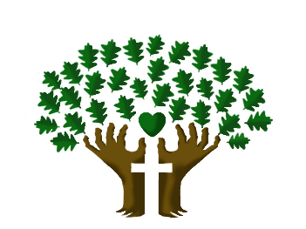

St. Luke’s Anglican Church, Palermo
3114 Dundas Street West,
Oakville, Ontario, L6M 4J3
Tel: 905-825-3364
Email: office@stlukepalermo.ca
Website: stlukepalermo.ca

Rector: The Rev. Garfield Wu
Email: rector@stlukepalermo.ca
Tel: 647-878-8650

Reader: Sylvia Young
Music Director: Janet Correia
Duty Warden: Kathy Lentz
Greeter: Peter Malue

