ST. LUKE’S ANGLICAN CHURCH, PALERMO
Fourth Sunday in Lent
Sunday, March 14, 2021 ◊ 10:30 am

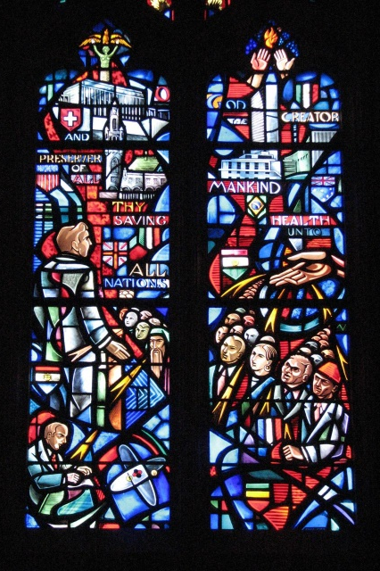

The Reverend Garfield Wu – Presider & Preacher

Welcome to St. Luke’s!

We are glad to be able to worship with you in person. Our service will look a little different than usual week as we take precautions to prevent the spread of COVID-19. Though this time may bring challenges, we know that nothing can separate us from the love of God.

None of us comes to church by accident. No matter what joys, burdens, or problems you bring with you this day, we pray that God’s grace will touch you and fill you with the hope and commitment to live your life with peace, courage, compassion, and love.

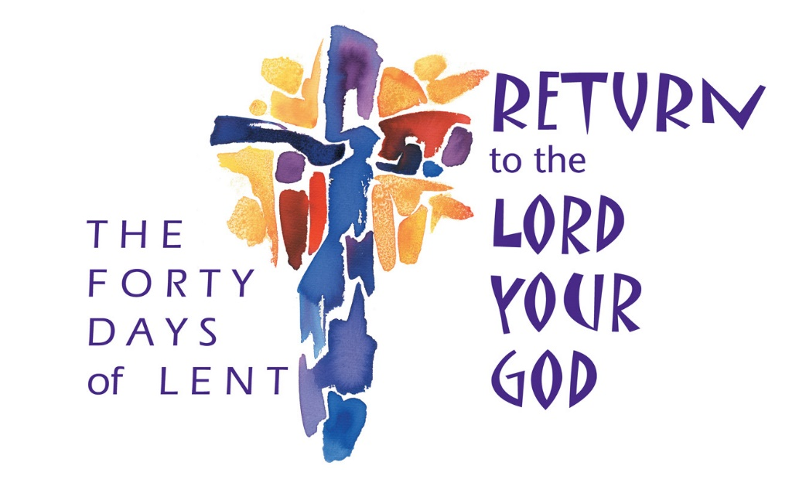

THE GATHERING OF THE COMMUNITY

Processional Hymn
God of Mercy, God of Grace – CP 341
1. God of mercy, God of grace,
show the brightness of your face;
shine upon us, Saviour, shine,
fill your church with light divine;
and your saving health extend
unto earth’s remotest end.

2. Let the people praise you, Lord;
be by all that live adored;
let the nations shout and sing
glory to their Saviour King;
at your feet their tribute pay,
and your holy will obey.

3. Let the people praise you, Lord;
earth shall then its fruits afford,
God to us all blessings give,
we to God devoted live:
all below and all above
one in joy and light and love.

Greeting
Celebrant: The grace of our Lord Jesus Christ
and the love of God and the fellowship of the Holy Spirit be with you all.
All: And also, with you.
Celebrant: Blessed be God, Father, Son, and Holy Spirit.
All: And blessed be God's kingdom forever. Amen.
Collect for Purity
Celebrant: Almighty God,
All: to whom all hearts are open, all desires known, and from you no secrets are hidden, cleanse the thoughts of our hearts by the inspiration of your Holy Spirit, that we may perfectly love you and worthily magnify your holy name, through Christ our Lord. Amen.

Kyrie Eleison
All: Lord, have mercy upon us,
Christ, have mercy upon us,
Lord, have mercy upon us.

Collect of the Day
Gracious Father, whose blessed Son Jesus Christ came from heaven to be the true bread which gives life to the world, evermore give us this bread, that he may live in us, and we in him, who lives and reigns with you and the Holy Spirit, one God, now and forever. Amen.

THE PROCLAMATION OF THE WORD

A Reading from the Book of Numbers
Numbers 21:4-9
From Mount Hor they set out by the way to the Red Sea, to go around the land of Edom; but the people became impatient on the way. The people spoke against God and against Moses, “Why have you brought us up out of Egypt to die in the wilderness? For there is no food and no water, and we detest this miserable food.” Then the Lord sent poisonous serpents among the people, and they bit the people, so that many Israelites died. The people came to Moses and said, “We have sinned by speaking against the Lord and against you; pray to the Lord to take away the serpents from us.” So Moses prayed for the people. And the Lord said to Moses, “Make a poisonous serpent, and set it on a pole; and everyone who is bitten shall look at it and live.” So Moses made a serpent of bronze, and put it upon a pole; and whenever a serpent bit someone, that person would look at the serpent of bronze and live.
The Word of the Lord.
Thanks be to God.

Gradual Hymn
Help Us Accept Each Other – SFGP 8 (v. 1, 2, 4)
1. Help us accept each other as Christ accepted us;
teach us as sister, brother, each person to embrace.
Be present, God, among us and bring us to believe
we are ourselves accepted and meant to love and live.

2. Teach us, O God, your lessons, as in our daily life
we struggle to be human and search for hope and faith.
Teach us to care for people, for all, not just for some,
to love them as we find them or as they may become.

The Gospel
John 3:14–21
The Lord be with you.
And also, with you.
The Holy Gospel of our Lord Jesus Christ, according to Luke.
Glory to you, Lord Jesus Christ.
And just as Moses lifted up the serpent in the wilderness, so must the Son of Man be lifted up, that whoever believes in him may have eternal life.
“For God so loved the world that he gave his only Son, so that everyone who believes in him may not perish but may have eternal life.
“Indeed, God did not send the Son into the world to condemn the world, but in order that the world might be saved through him. Those who believe in him are not condemned; but those who do not believe are condemned already, because they have not believed in the name of the only Son of God. And this is the judgment, that the light has come into the world, and people loved darkness rather than light because their deeds were evil. For all who do evil hate the light and do not come to the light, so that their deeds may not be exposed. But those who do what is true come to the light, so that it may be clearly seen that their deeds have been done in God.”

The Gospel of Christ.
Praise to you, Lord Jesus Christ.

4. Lord, for today’s encounters with all who are in need,
who hunger for acceptance, for righteousness and bread.
We need new eyes for seeing, new hands for holding on:
renew us with your Spirit; come, free us, make us one!

The Sermon
By the Rev. Garfield Wu

The Apostle’s Creed
Celebrant: | Let us confess the faith of our baptism as we say,
All: | I believe in God, the Father almighty, creator of heaven and earth.  I believe in Jesus Christ, his only Son, our Lord. He was conceived by the power of the Holy Spirit and born of the Virgin Mary. He suffered under Pontius Pilate, was crucified, died, and was buried. He descended to the dead. On the third day, he rose again. He ascended into heaven and is seated at the right hand of the Father. He will come again to judge the living and the dead.  I believe in the Holy Spirit, the holy catholic Church, the communion of saints, the forgiveness of sins, the resurrection of the body, and the life everlasting. Amen.

The Prayers of the People
Litany #14 – Lent (from BAS p. 121)
Celebrant: | With confidence and trust let us pray to the Lord, saying, “Lord, have mercy.”  For the one holy catholic and apostolic Church throughout the world, we pray to you, Lord.
All: | Lord, have mercy.
Celebrant: | For the mission of the Church, that in faithful witness it may preach the gospel to the ends of the earth, we pray to you, Lord.
All: | Lord, have mercy.
Celebrant: | For those preparing for baptism and for their teachers and sponsors, we pray to you, Lord.
All: | Lord, have mercy.
Celebrant: | For peace in the world, that a spirit of respect and reconciliation may grow among nations and peoples, we pray to you, Lord.
All: | Lord, have mercy.
Celebrant: | For the poor, the persecuted, the sick, and all who suffer; for refugees, prisoners, and all in danger; that they may be relieved and protected, we pray to you, Lord.
All: | Lord, have mercy.
Celebrant: | For all whom we have injured or offended, we pray to you, Lord.
All: | Lord, have mercy.
Celebrant: | For grace to amend our lives and to further the reign of God, we pray to you, Lord.
All: | Lord, have mercy.

Family Cycle of Prayer:
Peter & Allison Allen, Peter & Sandra Anderson, Lorna Bartman, David Beswick, James Black, John & Dianne Brice, Elizabeth Buchanan, and their families.

In the Diocese of Niagara:
St. Michael’s, Hamilton; the Rev. Jonathon Forbes, Rector; the Rev. Canon Frederick Roberts, Honorary Assistant; and all the people of that parish.
Let us take a moment to say the names of those we know to be in need, or allow those things are weighing heavy our on our hearts this day to come before the Lord. […]
So, we commend ourselves and all for whom we pray to the mercy and protection of our heavenly Father. Amen

Confession and Absolution
Celebrant: | Dear friends in Christ,  God is steadfast in love and infinite in mercy; he welcomes sinners and invites them to his table. Let us confess our sins, confident in God's forgiveness.
Celebrant: | Most merciful God,
All: | we confess that we have sinned against you in Thought, Word, and Deed, by what we have done, and by what we have left undone. We have not loved you with our whole heart; we have not loved our neighbours as ourselves. We are truly sorry, and we humbly repent. For the sake of your Son Jesus Christ, have mercy on us and forgive us, that we may delight in your will, and walk in your ways, to the glory of your name. Amen
Celebrant: | Almighty God have mercy upon you, pardon and deliver you from all your sins, confirm and strengthen you in all goodness, and keep you in eternal life; through Jesus Christ, our Lord.
All: | Amen.

The Peace
The peace of the Lord be always with you.
And also with you.

THE CELEBRATION OF THE EUCHARIST
Preparation of the Gifts
Offertory Hymn
I Am the Bread, The Bread of Life – CP 56

1. I am the bread, the bread of life;
who comes to me will never hunger.
I am the bread, the bread of heaven;
who feeds on me will never die.
And as you eat, remember me -
my body broken on the tree:
my life was given to set you free,
and I’m alive for evermore.

2. I am the vine, the living vine;
apart from me you can do nothing.
I am the vine, the real vine;
abide in me and I in you.
And as you drink, remember me -
my blood was shed upon the tree:
my life was given to set you free,
and I’m alive for evermore.

3. So eat this bread, and drink this wine,
and as you do, receive this life of mine.
All that I am, I give to you,
that you may live forevermore.

The Prayer over the Gifts
God of mercy and compassion, your Word calls us home to faith and love. Accept all we offer you this day, in the name of Jesus Christ the Lord. Amen.
The Great Thanksgiving (Eucharistic Prayer #1)
Celebrant:  People: | The Lord be with you.  And also, with you
Celebrant:  People: | Lift up your hearts.  We lift them to the Lord.
Celebrant:  People: | Let us give thanks to the Lord our God.  It is right to give our thanks and praise.
Celebrant: | It is indeed right that we should praise you, gracious God, for you created all things. You formed us in your own image: male and female you created us.  When we turned away from you in sin, you did not cease to care for us but opened a path of salvation for all people. You made a covenant with Israel, and through your servants, Abraham and Sarah gave the promise of a blessing to all nations.  Through Moses, you led your people from bondage into freedom; through the prophets, you renewed your promise of salvation. Therefore, with them, and with all your saints who have served you in every age, we give thanks and raise our voices to proclaim the glory of your name.
All | Holy, holy, holy Lord,  God of power and might, heaven and earth are full of your glory.  Hosanna in the highest.  Blessed is he who comes in the name of the Lord. Hosanna in the highest.
Celebrant | Holy God, source of life and goodness, all creation rightly gives you praise.  In the fullness of time, you sent your Son Jesus Christ, to share our human nature, to live and die as one of us, to reconcile us to you, the God and Father of all.  He healed the sick and ate and drank with outcasts and sinners; he opened the eyes of the blind and proclaimed the good news of your kingdom to the poor and to those in need. In all things, he fulfilled your gracious will.  On the night he freely gave himself to death, our Lord Jesus Christ took bread,  and when he had given thanks to you, he broke it, and gave it to his disciples, and said, "Take, eat this is my body which is given for you. Do this for the remembrance of me." After supper he took the cup of wine; and when he had given thanks, he gave it to them, and said,  "Drink this, all of you, this is my blood of the new covenant, which is shed for you and for many for the forgiveness of sins. Whenever you drink it, do this for the remembrance of me." Gracious God, his perfect sacrifice destroys the power of sin and death; by raising him to life, you give us life forevermore.  Therefore, we proclaim the mystery of faith.
All: | Christ has died.  Christ is risen.  Christ will come again
Celebrant: | Recalling his death, proclaiming his resurrection, and looking for his coming again in glory, we offer you, Father, this bread, and this cup.  Send your Holy Spirit upon us and upon these gifts, that all who eat and drink at this table may be one body and one holy people, a living sacrifice in Jesus Christ, our Lord.  Through Christ, with Christ, and in Christ, in the unity of the Holy Spirit, all glory is yours, almighty Father, now and forever.
People: | Amen.

The Lord's Prayer
Celebrant: | And now, as our Saviour Christ has taught us, we are bold to say:
All: | Our Father, who art in heaven,  hallowed be thy name,  thy kingdom come, thy will be done,  on earth as it is in heaven.  Give us this day our daily bread.  And forgive us our trespasses,  as we forgive those, who trespass against us.  And lead us not into temptation,  but deliver us from evil.  For thine is the kingdom,  the power, and the glory,  forever and ever. Amen.
The Breaking of the Bread
Celebrant: | We break this bread,
All: | Communion in Christ’s body once broken.
Celebrant: | Let your Church be the wheat which bears its fruit in dying.
All: | If we have died with him,  we shall live with him;  if we hold firm,  we shall reign with him.

The Communion
Celebrant:  All: | The gifts of God for the people of God.  Thanks be to God.
All: | Lamb of God, you take away the sins of the world: have mercy on us.  Lamb of God, you take away the sins of the world: have mercy on us.  Lamb of God, you take away the sins of the world: grant us peace.
The Eucharist
You are encouraged to receive the Holy Communion, standing or kneeling at the communion rail or at your request in your seat. In accordance with COVID-19 health guidelines, only the host will be distributed. Let us know if you require a gluten-free wafer. If you prefer a blessing only, please indicate so by crossing your arms. If you find it difficult to get to the altar, we will be honoured to bring the Holy Communion to you.

THE SENDING OF GOD'S PEOPLE

The Prayer after Communion
Giver of life, you enlighten all who come into the world. Fill our hearts with the splendour of your grace, that we may perfectly love you and worthily praise your holy name, through Jesus Christ the Lord. Amen.

Doxology
Celebrant: | Glory to God
All: | whose power, working in us, can do infinitely more than we can ask or imagine. Glory to God from generation to generation, in the Church and in Christ Jesus, forever and ever. Amen.
Blessing
The Celebrant blesses the people, and all respond,
Amen.

Announcements

Recessional Hymn
Rejoice, the Lord Is King – CP 379 (v. 1, 2, 4)

1. Rejoice, the Lord is King!
Your Lord and King adore!
Rejoice, give thanks and sing
and triumph evermore.
Lift up you heart, lift up your voice:
rejoice, again I say, rejoice!

2. Jesus the Saviour reigns,
the God of truth and love;
when he had purged our stains,
he took his seat above.
Lift up your heart, lift up your voice:
rejoice; again I say, rejoice!

4. He sits at God’s right hand
till all his foes submit,
and bow to his command,
and fall beneath his feet.
Lift up your heart, lift up your voice:
rejoice; again I say, rejoice!

The Dismissal
Go in peace. Serve the Lord, love others.
Thanks be to God.

Postlude
This liturgy is used with the permission of the Bishop of Niagara.
This service is adapted from The Book of Alternative Services (BAS). The Book of Alternative Services, copyright © 2019 by the General Synod of the Anglican Church of Canada; all rights reserved; reproduced under license. Common Worship, copyright © 2019 by the Archbishop's Council; used by permission; all rights reserved.

READINGS FOR NEXT SUNDAY
Jeremiah 31:31-34; John 12:20-33

ANNOUNCEMENTS
MORNING PRAYER AND BIBLE STUDY
Each Wednesday at 9:30 am
Our Morning Prayer services continue at St. Luke’s and online! Join us for a nourishing liturgy followed by a short Bible Study each Wednesday morning. This is a fun and friendly time of discussion and learning. No prior knowledge of the Bible is required. Come and check it out!

This Wednesday’s Readings:
Jeremiah 18:1-11; Psalm 101; Psalm 109:1-4, 20-30;
Romans 8:1-11; John 5:19-30.

Contact: garfield@stlukepalermo.ca
or 647-878-8650 for details!

Thank You MH3 Technologies!
Our online worship services have resumed at St. Luke’s, Palermo this week thanks to the hard work and talents of the technicians at MH3 Custom Technology Solutions, who have installed a new camera and audio set up that allows us to livestream our worship to you! We are extremely grateful to them.

Funding for this installation project has been provided by the Diocese of Niagara’s Walking on Water Grant. We thank God for all the donors from across the Diocese who have supported our ministries this year.

Support St. Luke’s and Double Your Donation!
Exciting news! As we have been working to stabilize our finances this year, two parishioners, Jo Stadnyk and and Aileen Li have generously offered to match donations to St. Luke's, above and beyond regular offerings, up to $1,000. This would give St. Luke’s a $2,000 boost!

Send in your donations to have your gift's impact DOUBLED! You can send a cheque, e-transfer or use our Canada Helps page. Please include the note "Donation Matching Campaign 2021" with your gift to ensure it is counted properly.

E-transfers can be sent to our Treasurer at: treasurer@stlukepalermo.ca

Thank you to Jo, Aileen, and all the generous donors who have made this possible, and to all parishioners who make our ministries happen!

St. Luke’s Palermo
Spring 2021 Gift Card Sale!
It’s time once again for St. Luke’s Gift Card Sale! This easy fundraiser lets you buy gift cards to many popular retailers, and support St. Luke’s, Palermo’s vital ministries and community services at the same time. While you get the full value of your card, a portion of the sale is donated to support our operations.

Orders are due Sunday, March 28.

Visit our website at
stlukepalermo.ca/giftcardsale/ to shop our gift cards!

St. Luke's Socializing Seniors Virtually Program Continues this Wednesday!
Program Runs each Wednesday at 11 am until May 26
St. Luke's is happy that our Seniors' Virtual Social Hour with Gabriella Mostacci Tolic, RP, MACP, is off to a great start. You are invited to participate in our program each Wednesday at 11 am, up to and including May 26. An exciting line up of group and individual workshops will be provided.

Please email us to register at office@stlukepalermo.ca and receive the Zoom Link. Please feel free to share this event with your friends, family and neighbours!

Health and Safety Protocol:

- Always wear a mask when in the Church.
- Please sanitize your hands as you come into the Church, going up for communion and coming down after communion and when you are leaving the building.
- Please take your bulletin home with you.

If you have any of the following symptoms, please contact your family doctor.

Symptoms of COVID-19 can vary from person to person. Symptoms may also vary in different age groups. Some of the more commonly reported symptoms include:
- new or worsening cough
- shortness of breath or difficulty breathing
- temperature equal to or over 38°C
- feeling feverish
- chills
- fatigue or weakness
- muscle or body aches
- new loss of smell or taste
- headache
- gastrointestinal symptoms (abdominal pain, diarrhea, vomiting)
- feeling very unwell
Children have been more commonly reported to have abdominal symptoms and skin changes or rashes.
In severe cases, the infection can lead to death.
Symptoms may take up to 14 days to appear after exposure to COVID-19.
Evidence indicates that the virus can be transmitted to others from someone who is infected but not showing symptoms. This includes people who:
- have not yet developed symptoms (pre-symptomatic)
- never develop symptoms (asymptomatic)
While experts know that these kinds of transmissions are happening among those in close contact or in close physical settings, it is not known to what extent. This means it is extremely important to follow the proven preventative measures.
For more information, please look online at

https://www.canada.ca/en/public-health/services/diseases/coronavirus-disease-covid-19.html

Thank you for joining us today.
We do hope that you will come again.
fb.me/stlukepalermo

@stlukepalermo

@stlukepalermo

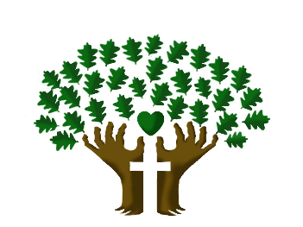

St. Luke’s Anglican Church, Palermo
3114 Dundas Street West,
Oakville, Ontario, L6M 4J3
Tel: 905-825-3364
Email: office@stlukepalermo.ca
Website: stlukepalermo.ca

Rector: The Rev. Garfield Wu
Email: rector@stlukepalermo.ca
Tel: 647-878-8650

Reader: Kathy Lentz
Music Director: Janet Correia
Duty Warden: Margie Simms
Greeter: Peter Malue

