ST. LUKE’S ANGLICAN CHURCH, PALERMO
Fourth Sunday in Advent
Sunday, December 20, 2020 ◊ 10:30 am

The Reverend Garfield Wu – Presider & Preacher

Welcome to St. Luke’s!

We are glad to be able to worship with you in person. Our service will look a little different than usual week as we take precautions to prevent the spread of COVID-19. Though this time may bring challenges, we know that nothing can separate us from the love of God.

None of us comes to church by accident. No matter what joys, burdens, or problems you bring with you this day, we pray that God’s grace will touch you and fill you with the hope and commitment to live your life with peace, courage, compassion, and love.

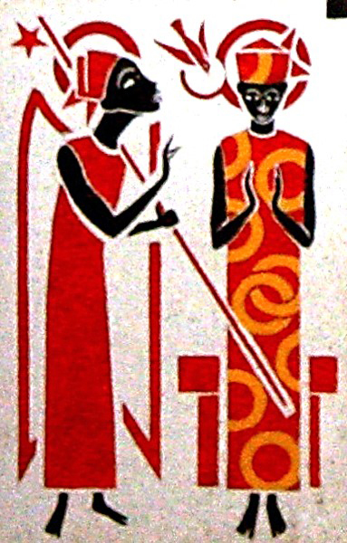

THE GATHERING OF THE COMMUNITY

Processional Hymn
Lo, He Comes with Clouds Descending – CP 114 (v. 1, 3, 4)
1. Lo, he comes with clouds descending,
once for favoured sinners slain;
thousand thousand saints attending
swell the triumph of his train:
hallelujah, hallelujah, hallelujah!
God appears on earth to reign.

3. Now redemption, long expected,
see in solemn pomp appear;
all his saints, on earth rejected,
thrill the trumpet sound to hear:
hallelujah, hallelujah, hallelujah!
See the day of God appear!

4. Yea, amen, let all adore thee,
high on thine eternal throne;
Saviour, take the power and glory;
claim the kingdom for thine own:
O come quickly! O come quickly! O come quickly!
Hallelujah! Come, Lord, come!

Greeting
Celebrant: The grace of our Lord Jesus Christ
and the love of God and the fellowship of the Holy Spirit be with you all.
All: And also, with you.
Celebrant: Blessed be God, Father, Son, and Holy Spirit.
All: And blessed be God's kingdom forever. Amen.
Collect for Purity
Celebrant: Almighty God,
All: to whom all hearts are open, all desires known, and from you no secrets are hidden, cleanse the thoughts of our hearts by the inspiration of your Holy Spirit, that we may perfectly love you and worthily magnify your holy name, through Christ our Lord. Amen.

Kyrie Eleison
All: Lord, have mercy upon us,
Christ, have mercy upon us,
Lord, have mercy upon us.

Collect of the Day
Heavenly Father, who chose the Virgin Mary, full of grace, to be the mother of our Lord and Saviour, now fill us with your grace, that we in all things may embrace your will and with her rejoice in your salvation; through Jesus Christ our Lord, who lives and reigns with you and the Holy Spirit, one God, now and forever. Amen.

THE PROCLAMATION OF THE WORD

A Reading from the First Letter to the Romans
Romans 16:25-27
Now to God who is able to strengthen you according to my gospel and the proclamation of Jesus Christ, according to the revelation of the mystery that was kept secret for long ages but is now disclosed, and through the prophetic writings is made known to all the Gentiles, according to the command of the eternal God, to bring about the obedience of faith—to the only wise God, through Jesus Christ, to whom be the glory forever! Amen.
The Word of the Lord.
Thanks be to God.

Gradual Hymn
In the Bleak Midwinter – CP 122 (v. 1, 3, 4)
1. In the bleak midwinter, frosty wind made moan,
earth stood hard as iron, water like a stone;
snow had fallen, snow on snow, snow on snow,
in the bleak midwinter, long ago.

3. Angels and archangels may have gathered there;
cherubim and seraphim thronged the air;
but his mother only in her maiden bliss,
worshipped the beloved with a kiss.

The Gospel
Luke 1:26-38
The Lord be with you.
And also, with you.
The Holy Gospel of our Lord Jesus Christ, according to Luke.
Glory to you, Lord Jesus Christ.
In the sixth month the angel Gabriel was sent by God to a town in Galilee called Nazareth, to a virgin engaged to a man whose name was Joseph, of the house of David. The virgin’s name was Mary. And he came to her and said, “Greetings, favored one! The Lord is with you.” But she was much perplexed by his words and pondered what sort of greeting this might be. The angel said to her, “Do not be afraid, Mary, for you have found favor with God. And now, you will conceive in your womb and bear a son, and you will name him Jesus. He will be great, and will be called the Son of the Most High, and the Lord God will give to him the throne of his ancestor David. He will reign over the house of Jacob forever, and of his kingdom there will be no end.” Mary said to the angel, “How can this be, since I am a virgin?” The angel said to her, “The Holy Spirit will come upon you, and the power of the Most High will overshadow you; therefore the child to be born will be holy; he will be called Son of God. And now, your relative Elizabeth in her old age has also conceived a son; and this is the sixth month for her who was said to be barren. For nothing will be impossible with God.” Then Mary said, “Here am I, the servant of the Lord; let it be with me according to your word.” Then the angel departed from her.
The Gospel of Christ.
Praise to you, Lord Jesus Christ.

4. What can I give him, poor as I am?
If I were a shepherd, I would bring a lamb;
if I were a wiseman, I would do my part;
yet what I can, I give him – give my heart.

The Sermon
By the Rev. Garfield Wu

Choir Anthem:
Hope is a Star

The Apostle’s Creed
Celebrant: | Let us confess the faith of our baptism as we say,
All: | I believe in God, the Father almighty, creator of heaven and earth.  I believe in Jesus Christ, his only Son, our Lord. He was conceived by the power of the Holy Spirit and born of the Virgin Mary. He suffered under Pontius Pilate, was crucified, died, and was buried. He descended to the dead. On the third day, he rose again. He ascended into heaven and is seated at the right hand of the Father. He will come again to judge the living and the dead.  I believe in the Holy Spirit, the holy catholic Church, the communion of saints, the forgiveness of sins, the resurrection of the body, and the life everlasting. Amen.

The Prayers of the People
Litany #12 – Advent (from BAS p. 119)
Celebrant: | O Wisdom, from the mouth of the Most High, you reign over all things to the ends of the earth: come and teach us how to live;
All: | Lord Jesus, come soon!
Celebrant: | O Lord, and head of the house of Israel, you appeared to Moses in the fire of the burning bush and you gave the law on Sinai: come with outstretched arm and ransom us;
All: | Lord Jesus, come soon!
Celebrant: | O Branch of Jesse, standing as a sign among the nations, all kings will keep silence before you and all peoples will summon you to their aid: come, set us free and delay no more;
All: | Lord Jesus, come soon!
Celebrant: | O Key of David and sceptre of the house of Israel, you open and none can shut; you shut and none can open: come and free the captives from prison;
All: | Lord Jesus, come soon!
Celebrant: | O Morning Star, splendour of the light eternal and bright Sun of righteousness: come and enlighten all who dwell in darkness and in the shadow of death;
All: | Lord Jesus, come soon!
Celebrant: | O King of the nations, you alone can fulfil their desires: Cornerstone, you make opposing nations one: come and save the creature you fashioned from clay.
All: | Lord Jesus, come soon!
Celebrant: | O Emmanuel, hope of the nations and their Saviour: come and save us, Lord our God;
All: | Lord Jesus, come soon!

Family Cycle of Prayer:
Derek & Kristen Yarnell, Gemma Young, Sylvia & Neil Young, Deqing Zhang & June Wu, and their families.

In the Diocese of Niagara:
We pray for the parish of St. Columba, St. Catharines; The Reverend William Alakas, Rector; and the people of that parish.
Let us take a moment to say the names of those we know to be in need, or allow those things are weighing heavy our on our hearts this day to come before the Lord. […]
So, we commend ourselves and all for whom we pray to the mercy and protection of our heavenly Father. Amen

Confession and Absolution
Celebrant: | Dear friends in Christ,  God is steadfast in love and infinite in mercy; he welcomes sinners and invites them to his table. Let us confess our sins, confident in God's forgiveness.
Celebrant: | Most merciful God,
All: | we confess that we have sinned against you in Thought, Word, and Deed, by what we have done, and by what we have left undone. We have not loved you with our whole heart; we have not loved our neighbours as ourselves. We are truly sorry, and we humbly repent. For the sake of your Son Jesus Christ, have mercy on us and forgive us, that we may delight in your will, and walk in your ways, to the glory of your name. Amen
Celebrant: | Almighty God have mercy upon you, pardon and deliver you from all your sins, confirm and strengthen you in all goodness, and keep you in eternal life; through Jesus Christ, our Lord.
All: | Amen.

The Peace
The peace of the Lord be always with you.
And also with you.

THE CELEBRATION OF THE EUCHARIST
Preparation of the Gifts
Offertory Hymn
O Come, All Ye Faithful – CP 118 (v. 1-3)

1. O come, all ye faithful, joyful and triumphant,
O come ye, O come ye to Bethlehem:
come and behold him, born the king of angels;

Refrain
O come, let us adore him,
O come, let us adore him,
O come, let us adore him, Christ the Lord.

2. God of God, Light of Light,
lo, he abhors not the virgin’s womb;
very God, begotten not created:
Refrain

3. Sing, choirs of angels, sing in exultation,
sing, all ye citizens of heaven above;
glory to God in the highest:
Refrain

The Prayer over the Gifts
Gracious God, by the power of the Spirit who sanctified the mother of your Son, make holy all we offer you this day. We ask this in the name of Jesus Christ the Lord. Amen.
The Great Thanksgiving (Eucharistic Prayer #4)
Celebrant:  People: | The Lord be with you.  And also, with you
Celebrant:  People: | Lift up your hearts.  We lift them to the Lord
Celebrant:  People: | Let us give thanks to the Lord our God.  It is right to give our thanks and praise.
Celebrant: | It is right to give you thanks and praise,  O Lord, our God, sustainer of the universe,  you are worthy of glory and praise.
All: | Glory to you for ever and ever.
Celebrant: | At your command all things came to be:  the vast expanse of interstellar space,  galaxies, suns, the planets in their courses,  and this fragile earth, our island home;  by your will they were created and have their being.
All: | Glory to you for ever and ever.
Celebrant: | From the primal elements  you brought forth the human race,  and blessed us with memory, reason, and skill; you made us the stewards of creation.
All: | Glory to you for ever and ever.
Celebrant: | But we turn against you, and betray your trust; and we turn against one another. Again and again you call us to return.  Through the prophets and sages you reveal your righteous law.  In the fullness of time you sent your Son, born of a woman, to be our Saviour.  He was wounded for our transgressions, and bruised for our iniquities. By his death he opened to us the way of freedom and peace.
All: | Glory to you for ever and ever.
Celebrant: | Therefore we praise you, joining with the heavenly chorus, with prophets, apostles, and martyrs, and with those in every generation who have looked to you in hope, to proclaim with them your glory, in their unending hymn:
All: | Holy, holy, holy Lord,  God of power and might, heaven and earth are full of your glory.  Hosanna in the highest.  Blessed is he who comes in the name of the Lord. Hosanna in the highest.
Celebrant: | Blessed are you, Lord our God,  for sending us Jesus, the Christ,  who on the night he was handed over  to suffering and death, took bread, said the blessing, broke the bread, gave it to his friends, and said, “Take this, and eat it:  this is my body which is given for you.  Do this for the remembrance of me.”  In the same way, after supper, he took the cup of wine; he gave you thanks, and said, “Drink this, all of you: this is my blood of the new covenant, which is shed for you and for many for the forgiveness of sins. Whenever you drink it, do this for the remembrance of me.”
All: | Glory to you for ever and ever.
Celebrant: | Gracious God, we recall the death of your Son Jesus Christ, we proclaim his resurrection and ascension, and we look with expectation for his coming as Lord of all the nations. We who have been redeemed by him, and made a new people by water and the Spirit, now bring you these gifts. Send your Holy Spirit upon us and upon this offering of your Church, that we who eat and drink at this holy table may share the divine life of Christ our Lord.
All: | Glory to you for ever and ever.
Celebrant: | Pour out your Spirit upon the whole earth  and make it your new creation. Gather your Church together from the ends of the earth into your kingdom, where peace and justice are revealed, that we, with all your people,  of every language, race, and nation, may share the banquet you have promised;  through Christ, with Christ, and in Christ,  all honour and glory are yours, creator of all.
People: | Glory to you for ever and ever. Amen.

The Lord's Prayer
Celebrant: | And now, as our Saviour Christ has taught us, we are bold to say:
All: | Our Father, who art in heaven,  hallowed be thy name,  thy kingdom come, thy will be done,  on earth as it is in heaven.  Give us this day our daily bread.  And forgive us our trespasses,  as we forgive those, who trespass against us.  And lead us not into temptation,  but deliver us from evil.  For thine is the kingdom,  the power, and the glory,  forever and ever. Amen.
The Breaking of the Bread
Celebrant: | God of promise, you prepare a banquet for us in your kingdom.
All: | Happy are those who are called to the supper of the Lamb.

The Communion
Celebrant:  All: | The gifts of God for the people of God.  Thanks be to God.
All: | Lamb of God, you take away the sins of the world: have mercy on us.  Lamb of God, you take away the sins of the world: have mercy on us.  Lamb of God, you take away the sins of the world: grant us peace.
The Eucharist
You are encouraged to receive the Holy Communion, standing or kneeling at the communion rail or at your request in your seat. In accordance with COVID-19 health guidelines, only the host will be distributed. Let us know if you require a gluten-free wafer. If you prefer a blessing only, please indicate so by crossing your arms. If you find it difficult to get to the altar, we will be honoured to bring the Holy Communion to you.
Guzheng Solo by Angela Zhang

THE SENDING OF GOD'S PEOPLE

The Prayer after Communion
Faithful God, in this sacrament we receive the promise of salvation. May we, like the Virgin Mary, be obedient to your will. We ask this in the name of Jesus Christ the Lord. Amen.

Doxology
Celebrant: | Glory to God
All: | whose power, working in us, can do infinitely more than we can ask or imagine. Glory to God from generation to generation, in the Church and in Christ Jesus, forever and ever. Amen.
Blessing
The Celebrant blesses the people, and all respond,
Amen.

Announcements

Recessional Hymn
Herald! Sound the Note of Judgement – CP 111

1. Herald! Sound the note of judgement,
warning note of right and wrong,
turning us from sin and sadness,
till once more we sing the song.

Refrain
Sound the trumpet! Tell the message!
Christ the Saviour King has come!

2. Herald! Sound the note of gladness!
Tell the news that Christ is here;
make a pathway through the desert
for the one who brings God near.
Refrain

3. Herald! Sound the note of pardon!
Those repenting are forgiven;
God restores the wayward children,
and to all new life is given.
Refrain

4. Herald! Sound the note of triumph!
Christ has come to share our life,
bringing God’s own love and power,
granting victory in our strife.
Refrain

The Dismissal
Go in peace. Serve the Lord, love others.
Thanks be to God.

Postlude
This liturgy is used with the permission of the Bishop of Niagara.
This service is adapted from The Book of Alternative Services (BAS). The Book of Alternative Services, copyright © 2019 by the General Synod of the Anglican Church of Canada; all rights reserved; reproduced under license. Common Worship, copyright © 2019 by the Archbishop's Council; used by permission; all rights reserved.

READINGS FOR NEXT SUNDAY
Galatians 4:4-7; Luke 2:22-40

ANNOUNCEMENTS
MORNING PRAYER AND BIBLE STUDY
ON BREAK until January 6, 2021
Our Morning Prayer services continue at St. Luke’s and online! Join us for a nourishing liturgy followed by a short Bible Study each Wednesday morning. This is a fun and friendly time of discussion and learning. No prior knowledge of the Bible is required. Come and check it out!

NOTE: There will be no Bible Study on
Wednesday, December. 23 or 30.

Contact: garfield@stlukepalermo.ca
or 647-878-8650 for details!

Reserve a Seat at St. Luke's Christmas Services Now!

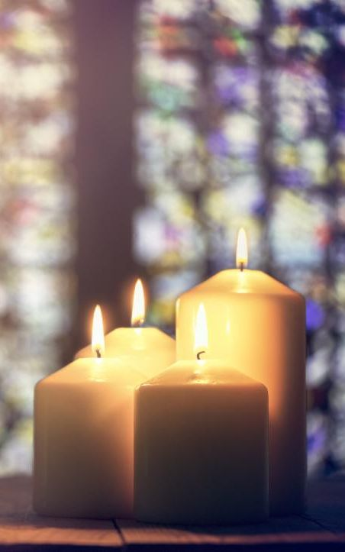
This Christmas, we will hold three services to celebrate Christmas Eve and Christmas Day. As you know, this year's Christmas services will look different due to the health and safety regulations to prevent the spread of COVID-19.

Due to limitations on capacity and physical distancing requirements, it is very important that all parishioners who want to attend sign up as soon as possible. Visit our website or contact Garfield Wu (rector@stlukepalermo.ca) today to register your family!

FAMILY CHRISTMAS EVE SERVICE - In Person & Online!
Date: Thursday, December 24
Time: 5:00 pm

CHRISTMAS EVE LESSONS & CAROLS SERVICE - Online
Date: Thursday, December 24
Time: 9:30 pm

CHRISTMAS DAY SERVICES - In Person & Online
Date: Friday, December 25
Time: 10:30 am

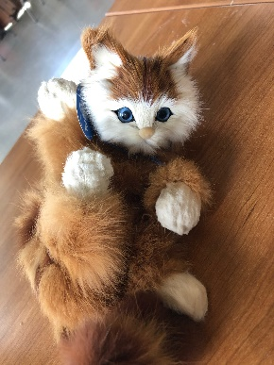
St. Luke’s has a Christmas Gift for You!
This past week, we received a very generous donation of Christmas gifts from a local family. These toys are meant to bring Christmas cheer to our parishioners at a time when we cannot gather as we normally would, and we will be happy to share one with you and your family! Feel free to take one during our Christmas Eve service, or on the following Sunday, December 27 at 10:30 am. If you aren’t able to come in person, contact us to make other arrangements.

Support St. Luke’s and Double Your Donation!
This fall, St. Luke’s is holding a special fundraiser to support our community services! An anonymous donor has offered to match all donations up to $3,000, which means your support will be doubled! Place your donation in an envelope marked “St. Luke’s Fundraiser,” or contact Richard at treasurer@stlukepalermo.ca to donate!

St. Luke’s Palermo
2020 Gift Card Sale!
Sales have now ended. Thank you everyone for your support!

Be sure to pick up any remaining cards this week!
Donations are Open to Support Nourishing Neighbours!
The Oakville Community Foundation has approved St. Luke’s Nourishing Neighbours COVID Relief Project for public fundraising in their GIVE Oakville Program! Visit St. Luke’s donation page on the GIVE Oakville website to make a donation, and be sure to share the webpage widely. Every dollar helps us cover the costs of running our fresh food program during the COVID pandemic.
Visit this link today to donate, and share it with others:
https://ocf.fcsuite.com/erp/donate/create?grant_id=8572

Health and Safety Protocol:

- Always wear a mask when in the Church.
- Please sanitize your hands as you come into the Church, going up for communion and coming down after communion and when you are leaving the building.
- Please take your bulletin home with you.

If you have any of the following symptoms, please contact your family doctor.

Symptoms of COVID-19 can vary from person to person. Symptoms may also vary in different age groups. Some of the more commonly reported symptoms include:
- new or worsening cough
- shortness of breath or difficulty breathing
- temperature equal to or over 38°C
- feeling feverish
- chills
- fatigue or weakness
- muscle or body aches
- new loss of smell or taste
- headache
- gastrointestinal symptoms (abdominal pain, diarrhea, vomiting)
- feeling very unwell
Children have been more commonly reported to have abdominal symptoms and skin changes or rashes.
In severe cases, the infection can lead to death.
Symptoms may take up to 14 days to appear after exposure to COVID-19.
Evidence indicates that the virus can be transmitted to others from someone who is infected but not showing symptoms. This includes people who:
- have not yet developed symptoms (pre-symptomatic)
- never develop symptoms (asymptomatic)
While experts know that these kinds of transmissions are happening among those in close contact or in close physical settings, it is not known to what extent. This means it is extremely important to follow the proven preventative measures.
For more information, please look online at

https://www.canada.ca/en/public-health/services/diseases/coronavirus-disease-covid-19.html

Thank you for joining us today.
We do hope that you will come again.
fb.me/stlukepalermo

@stlukepalermo

@stlukepalermo

St. Luke’s Anglican Church, Palermo
3114 Dundas Street West,
Oakville, Ontario, L6M 4J3
Tel: 905-825-3364
Email: office@stlukepalermo.ca
Website: stlukepalermo.ca

Rector: The Rev. Garfield Wu
Email: rector@stlukepalermo.ca
Tel: 647-878-8650

Reader: Dean Correia
Music Director: Janet Correia
Duty Warden: Gemma Young
Greeter: Peter Malue

