ST. LUKE’S ANGLICAN CHURCH, PALERMO
Third Sunday in Advent
Sunday, December 13, 2020 ◊ 10:30 am

The Reverend Garfield Wu – Presider & Preacher

Welcome to St. Luke’s!

We are glad to be able to worship with you in person. Our service will look a little different than usual week as we take precautions to prevent the spread of COVID-19. Though this time may bring challenges, we know that nothing can separate us from the love of God.

None of us comes to church by accident. No matter what joys, burdens, or problems you bring with you this day, we pray that God’s grace will touch you and fill you with the hope and commitment to live your life with peace, courage, compassion, and love.

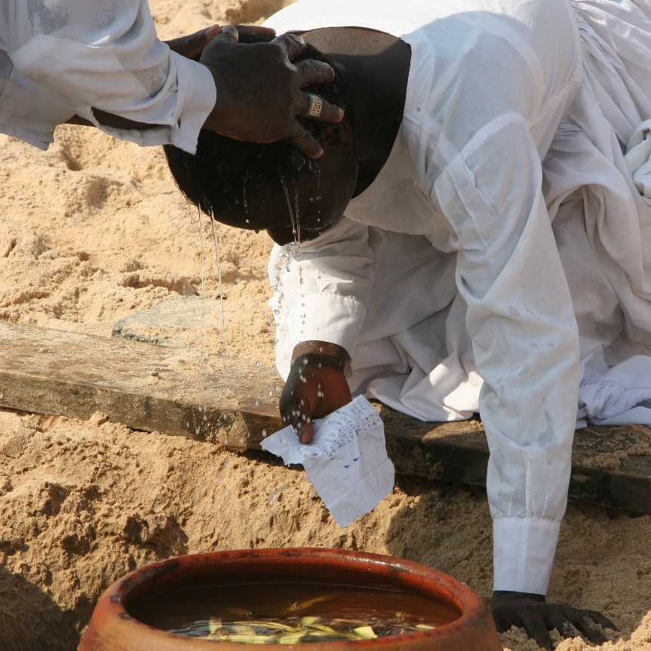

THE GATHERING OF THE COMMUNITY

Processional Hymn
On Jordan’s Bank, the Baptist’s Cry – CP 103 (v. 1-4)
1. On Jordan's bank, the Baptist's cry
announces that the Lord is nigh;
awake and harken, for he brings
glad tidings of the King of kings!

2. Then cleansed be every breast from sin:
make straight the way for God within,
Prepare we in our hearts a home,
where such a mighty guest may come.

3. For thou art our salvation, Lord,
our refuge, and our great reward;
Without thy grace we waste away,
like flowers that wither and decay.

4. To heal the sick stretch out thine hand,
and bid the fallen sinner stand;
shine forth, and let thy light restore
earth’s own true loveliness once more.

Greeting
Celebrant: The grace of our Lord Jesus Christ
and the love of God and the fellowship of the Holy Spirit be with you all.
All: And also, with you.
Celebrant: Blessed be God, Father, Son, and Holy Spirit.
All: And blessed be God's kingdom forever. Amen.
Collect for Purity
Celebrant: Almighty God,
All: to whom all hearts are open, all desires known, and from you no secrets are hidden, cleanse the thoughts of our hearts by the inspiration of your Holy Spirit, that we may perfectly love you and worthily magnify your holy name, through Christ our Lord. Amen.

Kyrie Eleison
All: Lord, have mercy upon us,
Christ, have mercy upon us,
Lord, have mercy upon us.

Collect of the Day
God of power and mercy, you call us once again to celebrate the coming of your Son. Remove those things which hinder love of you, that when he comes, he may find us waiting in awe and wonder for him who lives and reigns with you and the Holy Spirit, one God, now and forever. Amen.

THE PROCLAMATION OF THE WORD

A Reading from the First Letter to the Thessalonians
1 Thessalonians 5:16-24
Rejoice always, pray without ceasing, give thanks in all circumstances; for this is the will of God in Christ Jesus for you. Do not quench the Spirit. Do not despise the words of prophets, but test everything; hold fast to what is good; abstain from every form of evil.
May the God of peace himself sanctify you entirely; and may your spirit and soul and body be kept sound and blameless at the coming of our Lord Jesus Christ. The one who calls you is faithful, and he will do this.
The Word of the Lord.
Thanks be to God.

Gradual Hymn
He Came Down – CP 368
1. He came down that we may have love;
He came down that we may have love;
He came down that we may have love,
Hallelujah for evermore.

2. He came down that we may have peace;
He came down that we may have peace;
He came down that we may have peace,
Hallelujah for evermore.

The Gospel
John 1:6-8, 19-28
The Lord be with you.
And also, with you.
The Holy Gospel of our Lord Jesus Christ, according to John.
Glory to you, Lord Jesus Christ.
There was a man sent from God, whose name was John. He came as a witness to testify to the light, so that all might believe through him. He himself was not the light, but he came to testify to the light.
This is the testimony given by John when the Jews sent priests and Levites from Jerusalem to ask him, “Who are you?” He confessed and did not deny it, but confessed, “I am not the Messiah.” And they asked him, “What then? Are you Elijah?” He said, “I am not.” “Are you the prophet?” He answered, “No.” Then they said to him, “Who are you? Let us have an answer for those who sent us. What do you say about yourself?” He said,
“I am the voice of one crying out in the wilderness,
‘Make straight the way of the Lord,’”
as the prophet Isaiah said.
Now they had been sent from the Pharisees. They asked him, “Why then are you baptizing if you are neither the Messiah, nor Elijah, nor the prophet?” John answered them, “I baptize with water. Among you stands one whom you do not know, the one who is coming after me; I am not worthy to untie the thong of his sandal.” This took place in Bethany across the Jordan where John was baptizing.
The Gospel of Christ.
Praise to you, Lord Jesus Christ.

3. He came down that we may have joy;
He came down that we may have joy;
He came down that we may have joy,
Hallelujah for evermore.

The Sermon
By the Rev. Garfield Wu

Choir Anthem:
People in Darkness

The Apostle’s Creed
Celebrant: | Let us confess the faith of our baptism as we say,
All: | I believe in God, the Father almighty, creator of heaven and earth.  I believe in Jesus Christ, his only Son, our Lord. He was conceived by the power of the Holy Spirit and born of the Virgin Mary. He suffered under Pontius Pilate, was crucified, died, and was buried. He descended to the dead. On the third day, he rose again. He ascended into heaven and is seated at the right hand of the Father. He will come again to judge the living and the dead.  I believe in the Holy Spirit, the holy catholic Church, the communion of saints, the forgiveness of sins, the resurrection of the body, and the life everlasting. Amen.

The Prayers of the People
Litany #12 – Advent (from BAS p. 119)
Celebrant: | O Wisdom, from the mouth of the Most High, you reign over all things to the ends of the earth: come and teach us how to live;
All: | Lord Jesus, come soon!
Celebrant: | O Lord, and head of the house of Israel, you appeared to Moses in the fire of the burning bush and you gave the law on Sinai: come with outstretched arm and ransom us;
All: | Lord Jesus, come soon!
Celebrant: | O Branch of Jesse, standing as a sign among the nations, all kings will keep silence before you and all peoples will summon you to their aid: come, set us free and delay no more;
All: | Lord Jesus, come soon!
Celebrant: | O Key of David and sceptre of the house of Israel, you open and none can shut; you shut and none can open: come and free the captives from prison;
All: | Lord Jesus, come soon!
Celebrant: | O Morning Star, splendour of the light eternal and bright Sun of righteousness: come and enlighten all who dwell in darkness and in the shadow of death;
All: | Lord Jesus, come soon!
Celebrant: | O King of the nations, you alone can fulfil their desires: Cornerstone, you make opposing nations one: come and save the creature you fashioned from clay.
All: | Lord Jesus, come soon!
Celebrant: | O Emmanuel, hope of the nations and their Saviour: come and save us, Lord our God;
All: | Lord Jesus, come soon!

Family Cycle of Prayer:
Amy Tibble & Richard Barreiro, Doris & James Uduji, Bill Van Mol, Chenggang Wang & Ying Cheng, Lilly Wang, David & Marie Williams, and their families.

In the Diocese of Niagara:
We pray for the parish of St. Barnabas, St. Catharines; The Reverend Canon Dr. Michael Mondloch, Priest-in-Charge; The Reverend William Steinman, Assistant; and the people of that parish.
Let us take a moment to say the names of those we know to be in need, or allow those things are weighing heavy our on our hearts this day to come before the Lord. […]
So, we commend ourselves and all for whom we pray to the mercy and protection of our heavenly Father. Amen

Confession and Absolution
Celebrant: | Dear friends in Christ,  God is steadfast in love and infinite in mercy; he welcomes sinners and invites them to his table. Let us confess our sins, confident in God's forgiveness.
Celebrant: | Most merciful God,
All: | we confess that we have sinned against you in Thought, Word, and Deed, by what we have done, and by what we have left undone. We have not loved you with our whole heart; we have not loved our neighbours as ourselves. We are truly sorry, and we humbly repent. For the sake of your Son Jesus Christ, have mercy on us and forgive us, that we may delight in your will, and walk in your ways, to the glory of your name. Amen
Celebrant: | Almighty God have mercy upon you, pardon and deliver you from all your sins, confirm and strengthen you in all goodness, and keep you in eternal life; through Jesus Christ, our Lord.
All: | Amen.

The Peace
The peace of the Lord be always with you.
And also with you.

THE CELEBRATION OF THE EUCHARIST
Preparation of the Gifts
Offertory Hymn
Comfort, Comfort Ye My People – CP 100

1. Comfort, comfort ye my people;
speak ye peace: thus says your God.
Comfort those who sit in darkness
bowed beneath oppression’s load;
speak ye to Jerusalem
of the peace that waits for them:
tell her that her sins I cover,
and her warfare now is over.

2. Hark! The herald’s voice is calling
in the desert far and near,
calling us to new repentance
since the reign of God is here.
Oh, the warning call obey!
Now prepare for Christ a way;
let the valleys rise to meet him
and the hills bow down to greet him.

3. Make ye straight what long was crooked;
make the rougher places plain.
Let your hearts be true and humble
as befits Messiah’s reign.
For the glory of the Lord
now o’er earth is shed abroad,
and all flesh shall see the token
that God’s Word is never broken.

The Prayer over the Gifts
God of hope, renew in us the joy of your salvation and make us a living sacrifice to you, for the sake of Jesus Christ our Lord. Amen.
The Great Thanksgiving (Eucharistic Prayer #3)

Celebrant:  People: | The Lord be with you.  And also, with you
Celebrant:  People: | Lift up your hearts.  We lift them to the Lord
Celebrant:  People: | Let us give thanks to the Lord our God.  It is right to give our thanks and praise.
Celebrant: | Blessed are you, gracious God, creator of heaven and earth; we give you thanks and praise through Jesus Christ our Lord,  who in the fullness of time came among us in our flesh, and opened to us the way of salvation. Now we watch for the day when he will come again in power and great triumph to judge this world, that we, without shame or fear, may rejoice to behold his appearing. Therefore we praise you, joining our voices with angels and archangels and with all the company of heaven, who for ever sing this hymn to proclaim the glory of your name.
All: | Holy, holy, holy Lord,  God of power and might, heaven and earth are full of your glory.  Hosanna in the highest.  Blessed is he who comes in the name of the Lord. Hosanna in the highest.
Celebrant: | We give thanks to you, Lord our God,  for the goodness and love you have made known to us in creation; in calling Israel to be your people, in your Word spoken through the prophets; and above all in the Word made flesh, Jesus, your Son.  For in these last days you sent him to be incarnate from the Virgin Mary, to be the Saviour and Redeemer of the world. In him, you have delivered us from evil, and made us worthy to stand before you. In him, you have brought us out of error into truth, out of sin into righteousness, out of death into life.  On the night he was handed over to suffering and death, a death he freely accepted, our Lord Jesus Christ took bread; and when he had given thanks to you, he broke it, and gave it to his disciples, and said, "Take, eat: this is my body which is given for you. Do this for the remembrance of me."  After supper, he took the cup of wine; and when he had given thanks, he gave it to them, and said, "Drink this, all of you: this is my blood of the new covenant, which is shed for you and for many for the forgiveness of sins. Whenever you drink it, do this for the remembrance of me." Therefore, Father, according to his command,
All: | We remember his death,  We proclaim his resurrection,  We await his coming in glory;
Celebrant: | and we offer our sacrifice of praise and thanksgiving to you, Lord of all; presenting to you, from your creation, this bread and this wine.  We pray you, gracious God, to send your Holy Spirit upon these gifts, that they may be the sacrament of the body of Christ  and his blood of the new covenant. Unite us to your Son in his sacrifice, that we made acceptable in him, maybe sanctified by the Holy Spirit. In the fullness of time, reconcile all things in Christ, and make them new, and bring us to that city of light  where you dwell with all your sons and daughters; through Jesus Christ our Lord,  the firstborn of all creation, the head of the Church, and the author of our salvation.  By whom, and with whom, and in whom,  in the unity of the Holy Spirit,  all honour and glory are yours, almighty Father, now and for ever.
People: | Amen.
The Lord's Prayer
Celebrant: | And now, as our Saviour Christ has taught us, we are bold to say:
All: | Our Father, who art in heaven,  hallowed be thy name,  thy kingdom come, thy will be done,  on earth as it is in heaven.  Give us this day our daily bread.  And forgive us our trespasses,  as we forgive those, who trespass against us.  And lead us not into temptation,  but deliver us from evil.  For thine is the kingdom,  the power, and the glory,  forever and ever. Amen.

The Breaking of the Bread
Celebrant: | God of promise, you prepare a banquet for us in your kingdom.
All: | Happy are those who are called to the supper of the Lamb.

The Communion
Celebrant:  All: | The gifts of God for the people of God.  Thanks be to God.
All: | Lamb of God, you take away the sins of the world: have mercy on us.  Lamb of God, you take away the sins of the world: have mercy on us.  Lamb of God, you take away the sins of the world: grant us peace.

The Eucharist
You are encouraged to receive the Holy Communion, standing or kneeling at the communion rail or at your request in your seat. In accordance with COVID-19 health guidelines, only the host will be distributed. Let us know if you require a gluten-free wafer. If you prefer a blessing only, please indicate so by crossing your arms. If you find it difficult to get to the altar, we will be honoured to bring the Holy Communion to you.

Violin Solo by Alina Zhang

THE SENDING OF GOD'S PEOPLE

The Prayer after Communion
Merciful God, may this eucharist free us from our sins,
fill us with unending joy, and prepare us for the birthday of our Saviour. We ask this in the name of Jesus Christ, who is Lord now and forever. Amen.

Doxology
Celebrant: | Glory to God
All: | whose power, working in us, can do infinitely more than we can ask or imagine. Glory to God from generation to generation, in the Church and in Christ Jesus, forever and ever. Amen.
Blessing
The Celebrant blesses the people, and all respond,
Amen.

Announcements

Recessional Hymn
People, Look East! The Time is Near! – CP 91 (v. 1,2,4,5)

1. People, look east! The time is near
of the crowning of the year.
Make your house fair as you are able,
trim the hearth and set the table.
People, look east and sing today:
Love, the guest, is on the way.

2. Furrows, be glad! Though earth is bare,
one more seed is planted there:
give up your strength the seed to nourish,
that in course the flower may flourish.
People, look east and sing today:
Love, the rose, is on the way.

4. Stars, keep the watch: when night is dim
one more light the bowl shall brim,
shining beyond the frosty weather,
bright as sun and moon together.
People, look east and sing today:
Love, the star, is on the way.

5. Angels, announce with shouts of mirth
Christ who brings new life to earth.
Set every peak and valley humming
with the word, the Lord is coming.
People, look east and sing today:
Love, the Lord, is on the Way.

The Dismissal
Go in peace. Serve the Lord, love others.
Thanks be to God.

Postlude
This liturgy is used with the permission of the Bishop of Niagara.
This service is adapted from The Book of Alternative Services (BAS). The Book of Alternative Services, copyright © 2019 by the General Synod of the Anglican Church of Canada; all rights reserved; reproduced under license. Common Worship, copyright © 2019 by the Archbishop's Council; used by permission; all rights reserved.

READINGS FOR NEXT SUNDAY
Romans 16:25-27; Luke 1:26-38

ANNOUNCEMENTS
MORNING PRAYER AND BIBLE STUDY
Wednesdays @ 9:30am
Our Morning Prayer services continue at St. Luke’s and online! Join us for a nourishing liturgy followed by a short Bible Study each Wednesday morning. This is a fun and friendly time of discussion and learning. No prior knowledge of the Bible is required. Come and check it out!

This week’s readings:
Isaiah 9:8-17; Psalm 119:49-72;
2 Peter 2:1-10a; Luke 7:19-23

Contact: garfield@stlukepalermo.ca
or 647-878-8650 for details!

Reserve a Seat at St. Luke's Christmas Services Now!

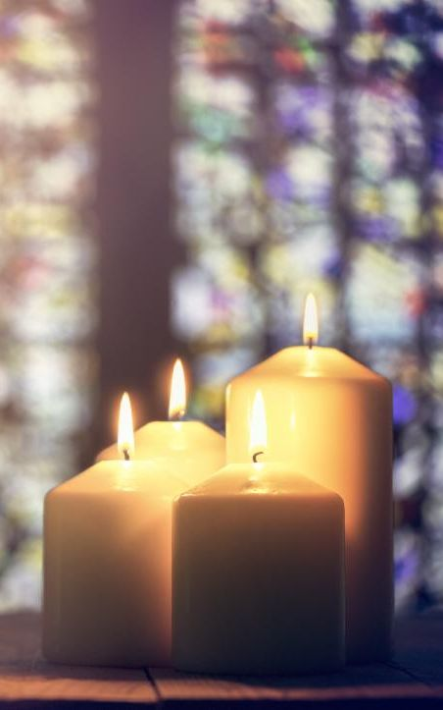
This Christmas, we will hold three services to celebrate Christmas Eve and Christmas Day. As you know, this year's Christmas services will look different due to the health and safety regulations to prevent the spread of COVID-19.

Due to limitations on capacity and physical distancing requirements, it is very important that all parishioners who want to attend sign up as soon as possible. Visit our website or contact Garfield Wu (rector@stlukepalermo.ca) today to register your family!

FAMILY CHRISTMAS EVE SERVICE - In Person & Online!
Date: Thursday, December 24
Time: 5:00 pm

CHRISTMAS EVE LESSONS & CAROLS SERVICE - Online
Date: Thursday, December 24
Time: 9:30 pm

CHRISTMAS DAY SERVICES - In Person & Online
Date: Friday, December 25
Time: 10:30 am

Support St. Luke’s and Double Your Donation!
This fall, St. Luke’s is holding a special fundraiser to support our community services! An anonymous donor has offered to match all donations up to $3,000, which means your support will be doubled! Place your donation in an envelope marked “St. Luke’s Fundraiser,” or contact Richard at treasurer@stlukepalermo.ca to donate!

St. Luke’s Palermo
2020 Gift Card Sale!
Sales have now ended. Thank you everyone for your support!

Be sure to pick up any remaining cards this week!
Donations are Open to Support Nourishing Neighbours!
The Oakville Community Foundation has approved St. Luke’s Nourishing Neighbours COVID Relief Project for public fundraising in their GIVE Oakville Program! Visit St. Luke’s donation page on the GIVE Oakville website to make a donation, and be sure to share the webpage widely. Every dollar helps us cover the costs of running our fresh food program during the COVID pandemic.
Visit this link today to donate, and share it with others:
https://ocf.fcsuite.com/erp/donate/create?grant_id=8572

Health and Safety Protocol:

- Always wear a mask when in the Church.
- Please sanitize your hands as you come into the Church, going up for communion and coming down after communion and when you are leaving the building.
- Please take your bulletin home with you.

If you have any of the following symptoms, please contact your family doctor.

Symptoms of COVID-19 can vary from person to person. Symptoms may also vary in different age groups. Some of the more commonly reported symptoms include:
- new or worsening cough
- shortness of breath or difficulty breathing
- temperature equal to or over 38°C
- feeling feverish
- chills
- fatigue or weakness
- muscle or body aches
- new loss of smell or taste
- headache
- gastrointestinal symptoms (abdominal pain, diarrhea, vomiting)
- feeling very unwell
Children have been more commonly reported to have abdominal symptoms and skin changes or rashes.
In severe cases, the infection can lead to death.
Symptoms may take up to 14 days to appear after exposure to COVID-19.
Evidence indicates that the virus can be transmitted to others from someone who is infected but not showing symptoms. This includes people who:
- have not yet developed symptoms (pre-symptomatic)
- never develop symptoms (asymptomatic)
While experts know that these kinds of transmissions are happening among those in close contact or in close physical settings, it is not known to what extent. This means it is extremely important to follow the proven preventative measures.
For more information, please look online at

https://www.canada.ca/en/public-health/services/diseases/coronavirus-disease-covid-19.html

Thank you for joining us today.
We do hope that you will come again.
fb.me/stlukepalermo

@stlukepalermo

@stlukepalermo

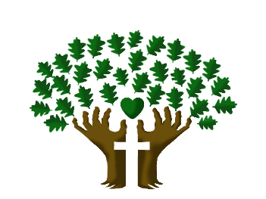

St. Luke’s Anglican Church, Palermo
3114 Dundas Street West,
Oakville, Ontario, L6M 4J3
Tel: 905-825-3364
Email: office@stlukepalermo.ca
Website: stlukepalermo.ca

Rector: The Rev. Garfield Wu
Email: rector@stlukepalermo.ca
Tel: 647-878-8650

Reader: Kathy Parker
Music Director: Janet Correia
Duty Warden: Margie Simms
Greeter: Peter Malue

