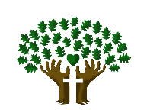
ST. LUKE’S ANGLICAN CHURCH, PALERMO
Eighteenth Sunday after Pentecost
Sunday, October 4, 2020 ◊ 10:30 am

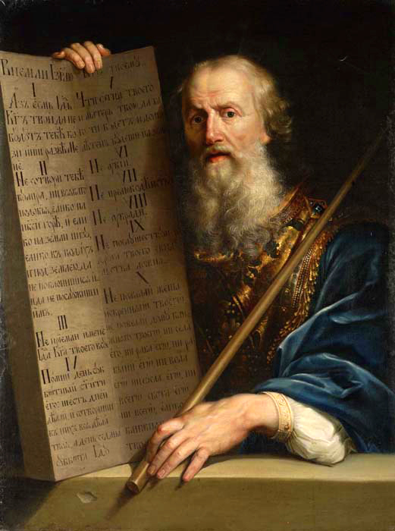

The Reverend Garfield Wu - Presider and Preacher

Welcome Back to St. Luke’s!

We are glad to be able to worship with you in person again. Our service will look a little different than usual this week as we take precautions to prevent the spread of COVID-19. Though this time may bring challenges, we know that nothing can separate us from the love of God.

None of us comes to church by accident. No matter what joys, burdens, or problems you bring with you this day, we pray that God’s grace will touch you and fill you with the hope and commitment to live your life with peace, courage, compassion, and love.
THE GATHERING OF THE COMMUNITY

Processional Hymn
I Heard the Voice of Jesus Say – CP 508 (verses 1, 2)
1. I heard the voice of Jesus say,
“Come unto me and rest;
lay down, thou weary one, lay down
thy head upon my breast.”
I came to Jesus as I was,
so weary, worn, and sad;
I found in him a resting place,
And he has made me glad.

2. I heard the voice of Jesus say,
“Behold, I freely give
the living water; thirsty one,
stoop down and drink, and live.”
I came to Jesus and I drank
of that life-giving stream;
my thirst was quenched,
my soul revived,
And now I live in him.

Greeting
Celebrant: The grace of our Lord Jesus Christ
and the love of God and the fellowship of the Holy Spirit be with you all.
All: And also, with you.
Celebrant: Blessed be God, Father, Son, and Holy Spirit.
All: And blessed be God's kingdom forever.
Amen.

Collect for Purity
Celebrant: Almighty God,
All: to whom all hearts are open, all desires known, and from you no secrets are hidden, cleanse the thoughts of our hearts by the inspiration of your Holy Spirit, that we may perfectly love you and worthily magnify your holy name, through Christ our Lord. Amen.

Glory to God

Celebrant: | Glory to God in the highest
All: | and peace to his people on earth.  Lord God, heavenly King,  almighty God, and Father,  we worship you; we give you thanks, we praise you for your glory.  Lord Jesus Christ, only Son of the Father,  Lord God, Lamb of God,  you take away the sin of the world:  have mercy on us,  you are seated at the right hand of the Father; receive our prayer.  For you alone are the Holy One,  you alone are the Lord,  you alone are the Most High,  Jesus Christ, with the Holy Spirit,  in the glory of God, the Father. Amen.

Collect of the Day
Almighty God, you have built your Church on the foundation of the apostles and prophets, Jesus Christ himself being the chief cornerstone. Join us together in unity of spirit by their teaching, that we may become a holy temple, acceptable to you; through Jesus Christ, our Lord, who lives and reigns with you and the Holy Spirit, one God, now and forever. Amen.

THE PROCLAMATION OF THE WORD

A Reading from the Book of Exodus
Exodus 20:1-4, 7-9, 12-20
Then God spoke all these words: I am the Lord your God, who brought you out of the land of Egypt, out of the house of slavery; you shall have no other gods before me. You shall not make for yourself an idol, whether in the form of anything that is in heaven above, or that is on the earth beneath, or that is in the water under the earth. You shall not make wrongful use of the name of the Lord your God, for the Lord will not acquit anyone who misuses his name. Remember the sabbath day and keep it holy. Six days you shall labour and do all your work. Honour your father and your mother so that your days may be long in the land that the Lord your God is giving you. You shall not murder. You shall not commit adultery. You shall not steal. You shall not bear false witness against your neighbour. You shall not covet your neighbour's house; you shall not covet your neighbour's wife, or male or female slave, or ox, or donkey, or anything that belongs to a neighbour. When all the people witnessed the thunder and lightning, the sound of the trumpet, and the mountain smoking, they were afraid and trembled and stood at a distance, and said to Moses, "You speak to us, and we will listen, but do not let God speak to us, or we will die." Moses said to the people, "Do not be afraid; for God has come only to test you and to put the fear of him upon you so that you do not sin."
The Word of the Lord.
Thanks be to God.

Gradual Hymn
Ye Servants of God – SFGP 94 (v. 1, 4)
1. You servants of God, your Saviour proclaim,
and publish abroad that wonderful name;
the name all-victorious of Jesus extol;
his kingdom is glorious and rules over all.
The Gospel
Matthew 21:33-46
The Lord be with you.
And also, with you.
The Holy Gospel of our Lord Jesus Christ, according to Matthew.
Glory to you, Lord Jesus Christ.

Jesus said, "Listen to another parable. There was a landowner who planted a vineyard, put a fence around it, dug a winepress in it, and built a watchtower. Then he leased it to tenants and went to another country. When the harvest time had come, he sent his slaves to the tenants to collect his produce. But the tenants seized his slaves and beat one, killed another, and stoned another. Again, he sent other slaves, more than the first; and they treated them in the same way. Finally, he sent his Son to them, saying, 'They will respect my son.' But when the tenants saw the Son, they said to themselves, 'This is the heir; come, let us kill him and get his inheritance.' So, they seized him, threw him out of the vineyard, and killed him. Now when the owner of the vineyard comes, what will he do to those tenants?" They said to him, "He will put those wretches to a miserable death and lease the vineyard to other tenants who will give him the produce at the harvest time." Jesus said to them, "Have you never read in the scriptures: 'The stone that the builders rejected has become the cornerstone; this was the Lord's doing, and it is amazing in our eyes'? Therefore, I tell you, the kingdom of God will be taken away from you and given to a people that produces the fruits of the kingdom. The one who falls on this stone will be broken to pieces, and it will crush anyone on whom it falls." When the chief priests and the Pharisees heard his parables, they realized that he was speaking about them. They wanted to arrest him, but they feared the crowds because they regarded him as a prophet.
The Gospel of Christ.
Praise to you, Lord Jesus Christ.

The Sermon
By the Rev. Garfield Wu
Choir Solo:
God, Whose Farm is All Creation

The Apostle’s Creed
Celebrant: | Let us confess the faith of our baptism as we say,
All: | I believe in God, the Father almighty, creator of heaven and earth.  I believe in Jesus Christ, his only Son, our Lord. He was conceived by the power of the Holy Spirit and born of the Virgin Mary. He suffered under Pontius Pilate, was crucified, died, and was buried. He descended to the dead. On the third day, he rose again. He ascended into heaven and is seated at the right hand of the Father. He will come again to judge the living and the dead.  I believe in the Holy Spirit, the holy catholic Church, the communion of saints, the forgiveness of sins, the resurrection of the body, and the life everlasting. Amen.

The Prayers of the People
Family Cycle of Prayer:
Peter & Allison Allen; Peter & Sandra Anderson; David Beswick; James Black; John & Dianne Brice; Simone & Maurizio Chen; Sheila Clarke; and their families.
In the Diocese of Niagara:
We pray for St. John, Jordan, The Reverend Pamela Guyatt, Rector, The Reverend Canon Ian Chadwick, Honorary Assistant, and the people of that parish.

Confession and Absolution
Celebrant: | Dear friends in Christ,  God is steadfast in love and infinite in mercy; he welcomes sinners and invites them to his table. Let us confess our sins, confident in God's forgiveness.
Celebrant: | Most merciful God,
All: | we confess that we have sinned against you in Thought, Word, and Deed, by what we have done, and by what we have left undone. We have not loved you with our whole heart; we have not loved our neighbours as ourselves. We are truly sorry, and we humbly repent. For the sake of your Son Jesus Christ, have mercy on us and forgive us, that we may delight in your will, and walk in your ways, to the glory of your name. Amen
Celebrant: | Almighty God have mercy upon you, pardon and deliver you from all your sins, confirm and strengthen you in all goodness, and keep you in eternal life; through Jesus Christ, our Lord.
All: | Amen

The Peace *
The peace of the Lord be always with you.
And also with you.

THE CELEBRATION OF THE EUCHARIST
Preparation of the Gifts
Offertory Hymn
Nearer, My God, to Thee – CP 538 (v. 1, 3)
1. Nearer, my God, to thee, nearer to thee!
Even though it be a cross that raiseth me,
still all my song would be, nearer, my God, to thee.
Refrain:
Nearer, my God, to thee,
nearer to thee!
3. There let the way appear, steps unto heaven;
all that thou sendest me, in mercy given;
angels to beckon me nearer, my God, to thee. Refrain

The Prayer over the Gifts
God of truth receive all we offer you this day. Make us worthy servants, strong to follow in the pattern of our Lord and Saviour Jesus Christ. Amen

The Great Thanksgiving (Eucharistic Prayer #1)
Celebrant:  People: | The Lord be with you.  And also, with you
Celebrant:  People: | Lift up your hearts.  We lift them to the Lord
Celebrant:  People: | Let us give thanks to the Lord our God.  It is right to give our thanks and praise.
Celebrant: | It is indeed right that we should praise you, gracious God, for you created all things. You formed us in your own image: male and female you created us.  When we turned away from you in sin, you did not cease to care for us but opened a path of salvation for all people. You made a covenant with Israel, and through your servants, Abraham and Sarah gave the promise of a blessing to all nations.  Through Moses, you led your people from bondage into freedom; through the prophets, you renewed your promise of salvation. Therefore, with them, and with all your saints who have served you in every age, we give thanks and raise our voices to proclaim the glory of your name.
All | Holy, holy, holy Lord,  God of power and might, heaven and earth are full of your glory.  Hosanna in the highest.  Blessed is he who comes in the name of the Lord. Hosanna in the highest.
Celebrant | Holy God, source of life and goodness, all creation rightly gives you praise.  In the fullness of time, you sent your Son Jesus Christ, to share our human nature, to live and die as one of us, to reconcile us to you, the God and Father of all.  He healed the sick and ate and drank with outcasts and sinners; he opened the eyes of the blind and proclaimed the good news of your kingdom to the poor and to those in need. In all things, he fulfilled your gracious will.  On the night he freely gave himself to death, our Lord Jesus Christ took bread,  and when he had given thanks to you, he broke it, and gave it to his disciples, and said, "Take, eat this is my body which is given for you. Do this for the remembrance of me." After supper he took the cup of wine; and when he had given thanks, he gave it to them, and said,  "Drink this, all of you, this is my blood of the new covenant, which is shed for you and for many for the forgiveness of sins. Whenever you drink it, do this for the remembrance of me." Gracious God, his perfect sacrifice destroys the power of sin and death; by raising him to life, you give us life forevermore.  Therefore, we proclaim the mystery of faith.
All: | Christ has died.  Christ is risen.  Christ will come again
Celebrant: | Recalling his death, proclaiming his resurrection, and looking for his coming again in glory, we offer you, Father, this bread, and this cup.  Send your Holy Spirit upon us and upon these gifts, that all who eat and drink at this table may be one body and one holy people, a living sacrifice in Jesus Christ, our Lord.  Through Christ, with Christ, and in Christ, in the unity of the Holy Spirit, all glory is yours, almighty Father, now and forever.
People: | Amen.

The Lord's Prayer
Celebrant: | And now, as our Saviour Christ has taught us, we are bold to say
All: | Our Father, who art in heaven,  hallowed be thy name,  thy kingdom come, thy will be done,  on earth as it is in heaven.  Give us this day our daily bread.  And forgive us our trespasses,  as we forgive those, who trespass against us.  And lead us not into temptation,  but deliver us from evil.  For thine is the kingdom,  the power,  and the glory,  forever and ever. Amen.

The Breaking of the Bread
Celebrant: | Creator of all, you gave us golden fields of wheat, whose many grains we have gathered and made into this one bread.
All: | So may your Church be gathered from the ends of the earth into your kingdom.

The Communion
Celebrant:  All: | The gifts of God for the people of God.  Thanks be to God.
All: | Lamb of God, you take away the sins of the world: have mercy on us.  Lamb of God, you take away the sins of the world: have mercy on us.  Lamb of God, you take away the sins of the world: grant us peace.

The Eucharist
You are encouraged to receive the Holy Communion, standing or kneeling at the communion rail or at your request in your seat. In accordance with COVID-19 health guidelines, only the host will be distributed. Let us know if you require a gluten-free wafer. If you prefer a blessing only, please indicate so by crossing your arms. If you find it difficult to get to the altar, we will be honoured to bring the Holy Communion to you.
Violin Solo during the Eucharist by Alina Zhang
THE SENDING OF GOD'S PEOPLE

The Prayer after Communion
Almighty God, may we who have been strengthened by this eucharist remain in your steadfast love, and show in our lives the saving mystery that we celebrate. This we ask in the name of Jesus Christ, the Lord. Amen.
Doxology
Celebrant: | Glory to God
All: | whose power, working in us, can do infinitely more than we can ask or imagine. Glory to God from generation to generation, in the Church and in Christ Jesus. forever and ever. Amen.
Blessing
The Celebrant blesses the people, and all respond,
Amen.
Announcements

Recessional Hymn
Lord, Dismiss Us with Your Blessing – CP 570 (v. 1, 2)

- Lord, dismiss us with your blessing;
fill our hearts with joy and peace;
let us each, your love possessing,
triumph in redeeming grace;
O refresh us, O refresh us,
travelling through the wilderness.

- Thanks we give and adoration
for the gospel’s joyful sound;
may the fruits of your salvation
in our hearts and lives abound;
may your presence, may your presence,
with us evermore be found.

The Dismissal
Go in peace. Serve the Lord, love others.
Thanks be to God.

Postlude

This liturgy is used with the permission of the Bishop of Niagara.

This service is adapted from The Book of Alternative Services (BAS). The Book of Alternative Services, copyright © 2019 by the General Synod of the Anglican Church of Canada; all rights reserved; reproduced under license. Common Worship, copyright © 2019 by the Archbishop's Council; used by permission; all rights reserved.

READINGS FOR NEXT SUNDAY
Philippians 4:1-9; Matthew 22:1-14

ANNOUNCEMENTS
Morning prayer and bible study
Wednesdays @ 9:30am
Our Morning Prayer services have started again! Join us for a nourishing liturgy followed by a short Bible Study each Wednesday morning. This is a fun and friendly time of discussion and learning.
No prior knowledge of the Bible is required. Come and check it out!

This week’s readings:
Micah 2:1-13; Psalm 119:145-176;
Acts 23:23-35; Luke 11:1-4

Contact: garfield@stlukepalermo.ca
or 647-878-8650 for details!

Join Us Next Week For
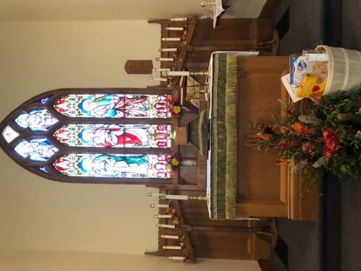
Harvest Thanksgiving

Sunday, October 10 at 10:30

We invite you to give thanks with us for all the gifts of God’s creation next week as we celebrate Thanksgiving! Though our celebrations may be smaller in size this year, our fellowship and joy need not decrease.

St. Luke’s Community Centre is Now Open!
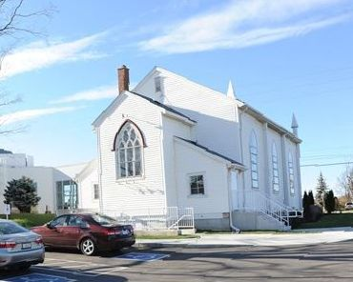
We are now welcoming users and guests back to use our facilities, in accordance with health and safety policies. If you know a person or group in need of program space, please call 905-825-3364 x82 or email community@stlukepalermo.ca

Health and Safety Protocol:

- Always wear a mask when in the Church.
- Please sanitize your hands as you come into the Church, going up for communion and coming down after communion and when you are leaving the building.
- Please take your bulletin home with you.

If you have any of the following symptoms, please contact your family doctor.

Symptoms of COVID-19 can vary from person to person. Symptoms may also vary in different age groups. Some of the more commonly reported symptoms include:
- new or worsening cough
- shortness of breath or difficulty breathing
- temperature equal to or over 38°C
- feeling feverish
- chills
- fatigue or weakness
- muscle or body aches
- new loss of smell or taste
- headache
- gastrointestinal symptoms (abdominal pain, diarrhea, vomiting)
- feeling very unwell
Children have been more commonly reported to have abdominal symptoms and skin changes or rashes.
In severe cases, the infection can lead to death.
Symptoms may take up to 14 days to appear after exposure to COVID-19.
Evidence indicates that the virus can be transmitted to others from someone who is infected but not showing symptoms. This includes people who:
- have not yet developed symptoms (pre-symptomatic)
- never develop symptoms (asymptomatic)
While experts know that these kinds of transmissions are happening among those in close contact or in close physical settings, it is not known to what extent. This means it is extremely important to follow the proven preventative measures.
For more information, please look online at

https://www.canada.ca/en/public-health/services/diseases/coronavirus-disease-covid-19.html

Thank you for joining us today.
We do hope that you will come again.
fb.me/stlukepalermo

@stlukepalermo

@stlukepalermo

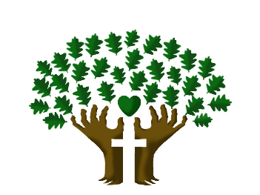

St. Luke’s Anglican Church, Palermo
3114 Dundas Street West,
Oakville, Ontario, L6M 4J3
Tel: 905-825-3364
Email: office@stlukepalermo.ca
Website: stlukepalermo.ca

Rector: The Rev. Garfield Wu
Email: rector@stlukepalermo.ca
Tel: 647-878-8650

Pastoral Associate: The Rev. Jody Balint
Reader: Kathy Parker
Music Director: Janet Correia
Duty Warden: Margie Simms
Altar Guild: Wendy Cousins
Greeter: Peter Malue

