ST. LUKE’S ANGLICAN CHURCH, PALERMO
Harvest Thanksgiving
Sunday, October 18, 2020 ◊ 10:30 am

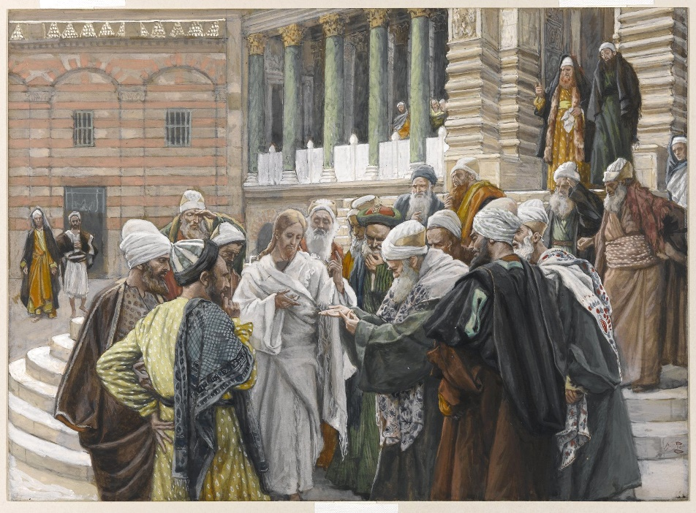

The Reverend Garfield Wu - Presider and Preacher

Welcome Back to St. Luke’s!

We are glad to be able to worship with you in person again. Our service will look a little different than usual this week as we take precautions to prevent the spread of COVID-19. Though this time may bring challenges, we know that nothing can separate us from the love of God.

None of us comes to church by accident. No matter what joys, burdens, or problems you bring with you this day, we pray that God’s grace will touch you and fill you with the hope and commitment to live your life with peace, courage, compassion, and love.
THE GATHERING OF THE COMMUNITY

Processional Hymn
Morning Has Broken – SFGP 103 (verses 1, 2)
1. Morning has broken like the first morning,
blackbird has spoken like the first bird.
Praise for the singing! Praise for the morning!
Praise for them, springing fresh from the Word!

2. Sweet the rain’s new fall, sunlit from heaven,
like the first dewfall on the first grass.
Praise for the sweetness of the wet garden,
sprung in completeness where God’s feet pass.

Greeting
Celebrant: The grace of our Lord Jesus Christ
and the love of God and the fellowship of the Holy Spirit be with you all.
All: And also, with you.
Celebrant: Blessed be God, Father, Son, and Holy Spirit.
All: And blessed be God's kingdom forever.
Amen.

Collect for Purity
Celebrant: Almighty God,
All: to whom all hearts are open, all desires known, and from you no secrets are hidden, cleanse the thoughts of our hearts by the inspiration of your Holy Spirit, that we may perfectly love you and worthily magnify your holy name, through Christ our Lord. Amen.

Glory to God

Celebrant: | Glory to God in the highest
All: | and peace to his people on earth.  Lord God, heavenly King,  almighty God, and Father,  we worship you; we give you thanks, we praise you for your glory.  Lord Jesus Christ, only Son of the Father,  Lord God, Lamb of God,  you take away the sin of the world:  have mercy on us,  you are seated at the right hand of the Father; receive our prayer.  For you alone are the Holy One,  you alone are the Lord,  you alone are the Most High,  Jesus Christ, with the Holy Spirit,  in the glory of God, the Father. Amen.

Collect of the Day
Almighty and everliving God, increase in us your gift of faith, that forsaking what lies behind and reaching out to what is before, we may run the way of your commandments and win the crown of everlasting joy; through Jesus Christ our Lord, who lives and reigns with you and the Holy Spirit, one God, now and forever. Amen.
THE PROCLAMATION OF THE WORD

A Reading from the 1st Letter of Paul to the Thessalonians
1 Thessalonians 1:1-10
Paul, Silvanus, and Timothy, To the church of the Thessalonians in God the Father and the Lord Jesus Christ: Grace to you and peace. We always give thanks to God for all of you and mention you in our prayers, constantly remembering before our God and Father your work of faith and labour of love and steadfastness of hope in our Lord Jesus Christ. For we know, brothers and sisters beloved by God, that he has chosen you, because our message of the gospel came to you not in word only, but also in power and in the Holy Spirit and with full conviction; just as you know what kind of persons we proved to be among you for your sake. And you became imitators of us and of the Lord, for in spite of persecution you received the word with joy inspired by the Holy Spirit, so that you became an example to all the believers in Macedonia and in Achaia. For the word of the Lord has sounded forth from you not only in Macedonia and Achaia, but in every place your faith in God has become known, so that we have no need to speak about it. For the people of those regions report about us what kind of welcome we had among you, and how you turned to God from idols, to serve a living and true God, and to wait for his Son from heaven, whom he raised from the dead Jesus, who rescues us from the wrath that is coming.
The Word of the Lord.
Thanks be to God.

Gradual Hymn
Come and Journey – CP 482 (v. 1, 5)
1. Come and journey with a Saviour
who has called us from our birth,
who has washed us in the waters,
and who loved us on the earth.

Refrain
Come and journey, come and journey
with a Saviour who has come.
We are all God’s sons and daughters;
in the Spirit we are one.

The Gospel
Matthew 22:15-22
The Lord be with you.
And also, with you.
The Holy Gospel of our Lord Jesus Christ, according to Matthew.
Glory to you, Lord Jesus Christ.
On the way to Jerusalem Jesus was going through the region between Samaria and Galilee. As he entered a village, ten lepers approached him. Keeping their distance, they called out, saying, “Jesus, Master, have mercy on us!” When he saw them, he said to them, “Go and show yourselves to the priests.” And as they went, they were made clean. Then one of them, when he saw that he was healed, turned back, praising God with a loud voice. He prostrated himself at Jesus, feet and thanked him. And he was a Samaritan. Then Jesus asked, “Were not ten made clean? But the other nine, where are they? Was none of them found to return and give praise to God except this foreigner?” Then he said to him, “Get up and go on your way; your faith has made you well.”
The Gospel of Christ.
Praise to you, Lord Jesus Christ.

5. Come and journey, journey upward.
Sing his praises, offer prayer.
In the storm and in the stillness
find his presence everywhere.

Refrain
Come and journey, come and journey
with a Saviour who has come.
We are all God’s sons and daughters;
in the Spirit we are one.

The Sermon
By the Rev. Garfield Wu

Choir Solo:
Lord Jesus, Of You I Will Sing

The Apostle’s Creed
Celebrant: | Let us confess the faith of our baptism as we say,
All: | I believe in God, the Father almighty, creator of heaven and earth.  I believe in Jesus Christ, his only Son, our Lord. He was conceived by the power of the Holy Spirit and born of the Virgin Mary. He suffered under Pontius Pilate, was crucified, died, and was buried. He descended to the dead. On the third day, he rose again. He ascended into heaven and is seated at the right hand of the Father. He will come again to judge the living and the dead.  I believe in the Holy Spirit, the holy catholic Church, the communion of saints, the forgiveness of sins, the resurrection of the body, and the life everlasting. Amen.

The Prayers of the People
Family Cycle of Prayer:
Patrick Donnelly; Colleen & Adam Douglas; Gary Duncan; Hyacinth Elliott; Kamille Elliott; Ruth Erskine; Chioma & Chinedu Ezomike; and their families.

In the Diocese of Niagara:
We pray for St. Paul, Jarvis; The Rev. Canon Richard Moorse, Rector; and the people of that parish.
Let us take a moment to say the names of those we know to be in need in silence, or allow those things are weighing heavy our on our hearts this day to come before the Lord.
So, we commend ourselves and all for whom we pray to the mercy and protection of our heavenly Father. Amen

Confession and Absolution
Celebrant: | Dear friends in Christ,  God is steadfast in love and infinite in mercy; he welcomes sinners and invites them to his table. Let us confess our sins, confident in God's forgiveness.
Celebrant: | Most merciful God,
All: | we confess that we have sinned against you in Thought, Word, and Deed, by what we have done, and by what we have left undone. We have not loved you with our whole heart; we have not loved our neighbours as ourselves. We are truly sorry, and we humbly repent. For the sake of your Son Jesus Christ, have mercy on us and forgive us, that we may delight in your will, and walk in your ways, to the glory of your name. Amen
Celebrant: | Almighty God have mercy upon you, pardon and deliver you from all your sins, confirm and strengthen you in all goodness, and keep you in eternal life; through Jesus Christ, our Lord.
All: | Amen

The Peace
The peace of the Lord be always with you.
And also with you.
THE CELEBRATION OF THE EUCHARIST
Preparation of the Gifts
Offertory Hymn
Lord, Enthroned in Heavenly Splendour – CP 84 (v. 1, 2, 5)

1. Lord, enthroned in heavenly splendour,
first begotten from the dead,
thou alone, our strong defender,
liftest up thy people’s head.
Alleluia, Jesus, true and living bread!

2. Here our humblest homage pay we;
here in loving reverence bow;
here for faith’s discernment pray we,
lest we fail to know thee now.
Alleluia, thou art here, we ask not how.

5. Life imparting heavenly Manna,
stricken rock with streaming side,
heaven and earth with loud hosanna
worship thee, the Lamb who died,
alleluia, risen, ascended, glorified!

The Prayer over the Gifts
Eternal God, your word inspires our faith. May we who offer you our praise trust you in all things. We ask this in the name of Jesus Christ the Lord. Amen.

The Great Thanksgiving (Eucharistic Prayer #1)
Celebrant:  People: | The Lord be with you.  And also, with you
Celebrant:  People: | Lift up your hearts.  We lift them to the Lord
Celebrant:  People: | Let us give thanks to the Lord our God.  It is right to give our thanks and praise.
Celebrant: | It is indeed right that we should praise you, gracious God, for you created all things. You formed us in your own image: male and female you created us.  When we turned away from you in sin, you did not cease to care for us but opened a path of salvation for all people. You made a covenant with Israel, and through your servants, Abraham and Sarah gave the promise of a blessing to all nations.  Through Moses, you led your people from bondage into freedom; through the prophets, you renewed your promise of salvation. Therefore, with them, and with all your saints who have served you in every age, we give thanks and raise our voices to proclaim the glory of your name.
All | Holy, holy, holy Lord,  God of power and might, heaven and earth are full of your glory.  Hosanna in the highest.  Blessed is he who comes in the name of the Lord. Hosanna in the highest.
Celebrant | Holy God, source of life and goodness, all creation rightly gives you praise.  In the fullness of time, you sent your Son Jesus Christ, to share our human nature, to live and die as one of us, to reconcile us to you, the God and Father of all.  He healed the sick and ate and drank with outcasts and sinners; he opened the eyes of the blind and proclaimed the good news of your kingdom to the poor and to those in need. In all things, he fulfilled your gracious will.  On the night he freely gave himself to death, our Lord Jesus Christ took bread,  and when he had given thanks to you, he broke it, and gave it to his disciples, and said, "Take, eat this is my body which is given for you. Do this for the remembrance of me." After supper he took the cup of wine; and when he had given thanks, he gave it to them, and said,  "Drink this, all of you, this is my blood of the new covenant, which is shed for you and for many for the forgiveness of sins. Whenever you drink it, do this for the remembrance of me." Gracious God, his perfect sacrifice destroys the power of sin and death; by raising him to life, you give us life forevermore.  Therefore, we proclaim the mystery of faith.
All: | Christ has died.  Christ is risen.  Christ will come again
Celebrant: | Recalling his death, proclaiming his resurrection, and looking for his coming again in glory, we offer you, Father, this bread, and this cup.  Send your Holy Spirit upon us and upon these gifts, that all who eat and drink at this table may be one body and one holy people, a living sacrifice in Jesus Christ, our Lord.  Through Christ, with Christ, and in Christ, in the unity of the Holy Spirit, all glory is yours, almighty Father, now and forever.
People: | Amen.

The Lord's Prayer
Celebrant: | And now, as our Saviour Christ has taught us, we are bold to say:
All: | Our Father, who art in heaven,  hallowed be thy name,  thy kingdom come, thy will be done,  on earth as it is in heaven.  Give us this day our daily bread.  And forgive us our trespasses,  as we forgive those, who trespass against us.  And lead us not into temptation,  but deliver us from evil.  For thine is the kingdom,  the power, and the glory,  forever and ever. Amen.

The Breaking of the Bread
Celebrant: | Creator of all, you gave us golden fields of wheat, whose many grains we have gathered and made into this one bread.
All: | So may your Church be gathered from the ends of the earth into your kingdom.

The Communion
Celebrant:  All: | The gifts of God for the people of God.  Thanks be to God.
All: | Lamb of God, you take away the sins of the world: have mercy on us.  Lamb of God, you take away the sins of the world: have mercy on us.  Lamb of God, you take away the sins of the world: grant us peace.

The Eucharist
You are encouraged to receive the Holy Communion, standing or kneeling at the communion rail or at your request in your seat. In accordance with COVID-19 health guidelines, only the host will be distributed. Let us know if you require a gluten-free wafer. If you prefer a blessing only, please indicate so by crossing your arms. If you find it difficult to get to the altar, we will be honoured to bring the Holy Communion to you.
Violin Solo during the Eucharist by Alina Zhang
“Jesu, Joy of Man's Desire”

THE SENDING OF GOD'S PEOPLE
The Prayer after Communion
God of peace, you have nourished us in this sacrament with the body and blood of Christ. May we who have taken holy things keep faith in our hearts and lives, in the name of Jesus Christ the Lord. Amen.

Doxology
Celebrant: | Glory to God
All: | whose power, working in us, can do infinitely more than we can ask or imagine. Glory to God from generation to generation, in the Church and in Christ Jesus. forever and ever. Amen.

Blessing
The Celebrant blesses the people, and all respond,
Amen.
Announcements

Recessional Hymn
Praise the Lord, Sing Hallelujah – CP 317 (v. 1, 3)

1. Praise the Lord, sing hallelujah,
from the heavens praise God’s name;
praise the Lord, our great Creator;
all you angels, praise proclaim.
All you hosts, together praising,
sun and moon and stars on high;
praise the Lord, O heavens of heavens,
and the floods above the sky.

3. All you fruitful trees and cedars,
every hill and mountain high,
creeping things and beasts and cattle,
birds that in the heavens fly,
kings of earth and all you people,
princes great, earth’s judges all:
praise God’s name, young men and maidens,
agèd men, and children small.

The Dismissal
Go in peace. Serve the Lord, love others.
Thanks be to God.

Postlude
This liturgy is used with the permission of the Bishop of Niagara.
This service is adapted from The Book of Alternative Services (BAS). The Book of Alternative Services, copyright © 2019 by the General Synod of the Anglican Church of Canada; all rights reserved; reproduced under license. Common Worship, copyright © 2019 by the Archbishop's Council; used by permission; all rights reserved.

READINGS FOR NEXT SUNDAY
1 Thessalonians 2:1-8; Matthew 22:34-46

ANNOUNCEMENTS
MORNING PRAYER AND BIBLE STUDY
Wednesdays @ 9:30am
Our Morning Prayer services have started again! Join us for a nourishing liturgy followed by a short Bible Study each Wednesday morning. This is a fun and friendly time of discussion and learning. No prior knowledge of the Bible is required. Come and check it out!

This week’s readings:
Sirach 7:4-14; Psalm 38;
Revelation 8:1-13; Luke 12:39-48

Contact: garfield@stlukepalermo.ca
or 647-878-8650 for details!

invites you to a FREE film screening
This Wednesday, October 21 at 7 pm

Join others in our GSS community to watch this INSPIRING and FREE film, from the comfort of your own home!
RSVP at http://bit.ly/2040GSSscreening and a link to the event will be returned in your Order Confirmation.

Make a Difference this Christmas with…
World of Gifts
Looking for easy, low-contact gift ideas this Christmas? Instead of a gift from Amazon, consider supporting those in need with the PWRDF World of Gift catalogue!
Browse the catalogue online now at:
pwrdf.org/worldofgifts

Support St. Luke’s this Fall and Double Your Donation!
This fall, St. Luke’s is holding a special fundraiser to support our community services! An anonymous donor has offered to match all donations up to $3,000, which means your support will be doubled! Place your donation in an envelope marked “St. Luke’s Fundraiser,” or contact Richard at treasurer@stlukepalermo.ca to donate!

Health and Safety Protocol:

- Always wear a mask when in the Church.
- Please sanitize your hands as you come into the Church, going up for communion and coming down after communion and when you are leaving the building.
- Please take your bulletin home with you.

If you have any of the following symptoms, please contact your family doctor.

Symptoms of COVID-19 can vary from person to person. Symptoms may also vary in different age groups. Some of the more commonly reported symptoms include:
- new or worsening cough
- shortness of breath or difficulty breathing
- temperature equal to or over 38°C
- feeling feverish
- chills
- fatigue or weakness
- muscle or body aches
- new loss of smell or taste
- headache
- gastrointestinal symptoms (abdominal pain, diarrhea, vomiting)
- feeling very unwell
Children have been more commonly reported to have abdominal symptoms and skin changes or rashes.
In severe cases, the infection can lead to death.
Symptoms may take up to 14 days to appear after exposure to COVID-19.
Evidence indicates that the virus can be transmitted to others from someone who is infected but not showing symptoms. This includes people who:
- have not yet developed symptoms (pre-symptomatic)
- never develop symptoms (asymptomatic)
While experts know that these kinds of transmissions are happening among those in close contact or in close physical settings, it is not known to what extent. This means it is extremely important to follow the proven preventative measures.
For more information, please look online at

https://www.canada.ca/en/public-health/services/diseases/coronavirus-disease-covid-19.html

Thank you for joining us today.
We do hope that you will come again.
fb.me/stlukepalermo

@stlukepalermo

@stlukepalermo

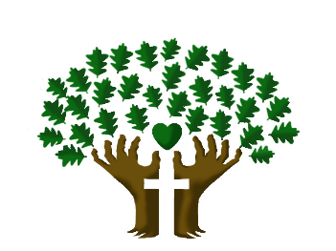

St. Luke’s Anglican Church, Palermo
3114 Dundas Street West,
Oakville, Ontario, L6M 4J3
Tel: 905-825-3364
Email: office@stlukepalermo.ca
Website: stlukepalermo.ca

Rector: The Rev. Garfield Wu
Email: rector@stlukepalermo.ca
Tel: 647-878-8650

Pastoral Associate: The Rev. Jody Balint
Reader: Sylvia Young
Music Director: Janet Correia
Duty Warden: Margie Simms
Altar Guild: Karen Ramcharan
Greeter: Peter Malue

