St. Luke’s Anglican Church, Palermo, Oakville

Pre-Authorized Giving Form

At this time, we ask that you mail directly to the Synod Office.
Cathedral Place
252 James St. North
Hamilton, Ontario
L8R 2L3

At St. Luke’s Palermo, we represent a community of family and friends with a shared vision to empower people to learn about God through scripture, influence the world in a Christ-like manner, and find peace, love, hope, and joy in God. Together we live out our core values in the world.

On this shared path, we pool our resources gladly. We chip in with the work required and stand ready to give a hand as we’re able. We also accept a hand of support when it is needed. By pitching in together with our time, talents and treasure, we grow as individuals spiritually as we help to grow the spirit of good in our local community and beyond.

When you use Pre-Authorized Giving, it not only helps our church community plan its annual budget. It means our church can plan its ministries. It enables us to move from budget talk to ministry, outreach, activism, prayer and caring for one another. It means we can focus more on why we exist as a community of believers rather than how we’re going to make ends meet.

Thank you for your support of
St. Luke Palermo, Oakville and its ministries.

You make a difference.

St. Luke’s Anglican Church, Palermo, Oakville
If you prefer to use your Credit Card for Pre-Authorized Giving, please go online to
https://niagaraanglican.ca/parish/st-luke-oakville

Note: you do not need to use this paper form for PAG when using your credit card.

New* Increase Decrease Change Banking* Cancel

Name(S) __________________________________________________________________________________________
Address____________________________________________________________________________________________________________________________________________________________________________________________
City ______________________________________ Postal Code _______________________
Phone ___________________________________ Email ____________________________

* For New or Changed Banking, please provide a void cheque OR complete the table:

Cheque  Number  (not needed) |  |  |  | Transit  (Branch Number) |  |  |  |  |  | Financial  Institutional  Number |  |  |  | Designation Number |  |  |  |  |  | Account Number

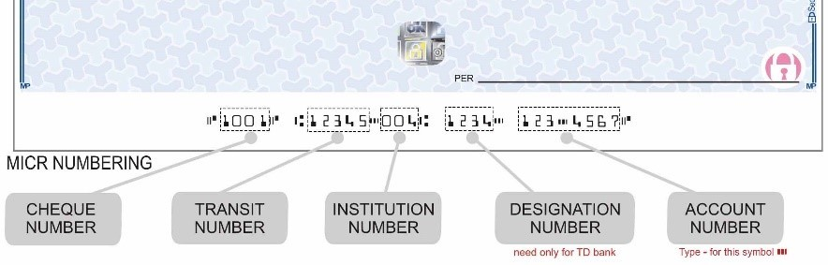

Payments can be taken on any numerical day of the month, i.e., 1st, 15th, 25th, etc.) Please indicate below.

I/we hereby authorize you to debit my/our account each month on the _______________________ (1st, 15th, etc.) in the amount of $ ______________ payable to the Diocese of Niagara on behalf of the St. Luke Palermo Anglican Church, Oakville. ** Your treatment of each payment shall be the same as if I/we had personally issued a cheque authorizing you to pay as indicated and to debit my/our account accordingly.

This authorization may be cancelled upon written notice.
Please note that we must receive any change by the 15th of the month for it to take effect for the following month.

Signature (1) ____________________________________________ Date ____________________________

Signature (2) ____________________________________________ Date ____________________________

**The Diocese of Niagara remits Pre-Authorized Giving donations back to St. Luke Palermo Anglican Church Oakville. Please contact the church office at (519) 856-9211 with any questions or to make any changes.

